These markings are per AWWA (American Water Works Assoc.) Adopted by the NFPA
5.1 Classification of Hydrants.
Hydrants should be classified in accordance with their rated capacities [at 20 psi (1.4 bar) residual pressure or other designated value] as follows:
(1) Class AA - Rated capacity of 1500 gprn (5680 L/min) or greater
(2) Class A - Rated capacity of 1000-1499 gpm (3785-5675 L/min)
(3) Class B - Rated capacity of 500-999 gprn (1900-3780 L/min )
(4) Class C - Rated capacity of less than 500 gpm (1900 L/min)

5.2 Marking of Hydrants.
Class | Color | Flow Capacity
AA | Light Blue Bonnet  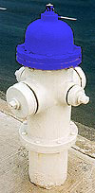 | 1,500 gpm and above
A | Green Bonnet  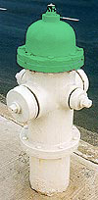 | 1,000 gpm or greater
B | Orange Bonnet  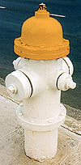 | 500 to 1,000 gpm
C | Red Bonnet  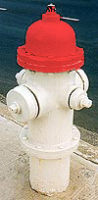 | Less than 500 gpm
White Bonnet
Means below 500 and is being tested
Note what will also change is..:
Body Color
GREEN | Over 120 p.s.i | Extremely high pressure (caution!)
ORANGE/YELLOW | 50-120 p.s.i. | "Normal" pressure range
RED | Below 50 p.s.i. | Must be "pumped"

5.2 Marking of Hydrants.
5.2.1 Public Hydrants.
5.2.1.1 All barrels are to be chrome yellow except in cases where another color has already been adopted.
5.2.1.2 The tops and nozzle caps should be painted with the following capacity-indicating color scheme to provide simplicity and consistency with colors used in signal work for safety, danger, and intermediate condition:
Class AA- Light blue
Class A - Green
Class B - Orange
Class C - Red
5.2.1.3 For rapid identification at night, it is recommended that the capacity colors be of a reflective-type paint.

FLOW RATE AND NUMBER OF HYDRANT OUTLETS REQUIRED TO FLUSH PIPELINES
Pipe Diameter,  (inches) | Flow Required to Produce Velocity of Approx. 2.5 ft/s in Main  (gpm) | Number 2.5 inch (65mm) Hydrant Outlets
4 | 100 | 1
6 | 200 | 1
8 | 400 | 1
10 | 600 | 1
12 | 900 | 2
16 | 1600 | 2

In general, all Private Fire Hydrants are required to be painted solid RED, or a color that distinguishes them from a Public hydrant. OSHA requires that water sources that are non-potable be painted VIOLET

Body Colors
WHITE | Public System Hydrant
YELLOW | Private System Hydrant | Connected to public water main
RED | Special Operation Hydrant
VIOLET | Non Potable Supply | Effuent, pond or lake supply

Some Cities have …

Body Colors:
WHITE | Public System Hydrant | 4” or Smaller main
RED | Public System Hydrant | 6” main
ORANGE//YELLOW | Public System Hydrant | 8” and 10” main
GREEN | Public System Hydrant | 12” or larger main

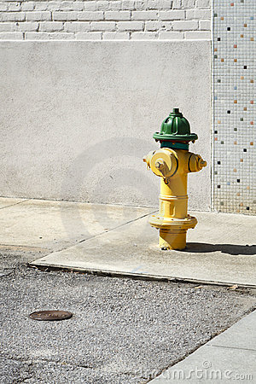  1000 GPM+ 12 to 18 inch diameter main | 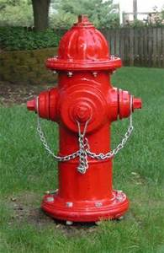  Private Service Main, less than 500 GPM. 6” main

In addition to these fire department applied markings, one may notice Roman numerals and other indicators painted in red. These markings indicate the location of the street shutoff valve which would need to be accessed in order to shut down the hydrant in the event it was knocked off or supply needed to be shut down for repairs.

Regulated Mains
We also have some neighborhoods in very high pressure areas where the water mains themselves are fed through pressure regulators so that water supplied to domestic users is not so extreme that it could damage water meters and plumbing. In these instances it is of critical importance to shut fire hydrants down slowly in order to prevent damage to water mains and system regulator sets. The orange "R" in a circle is a warning to fire fighters that the hydrant is on a regulator supplied pressure zone.
Orange Arrow | -> | Indicates direction of water flow  on a "dead end" main
Orange Arrow and  vertical bar | ->| | Indicates last hydrant and  direction of water flow  on a "dead end" main
Orange "R" in a circle | ® | Indicates hydrant is on a  regulated pressure zone

