Go here:
https://aca.slcgov.com/Citizen/Welcome.aspx?
And login.
On the Home tab under Building, choose Building > Apply for a Permit
On the Home tab under Building, choose Building > Apply for a Permit  Accept the Agreement that will pop up. | 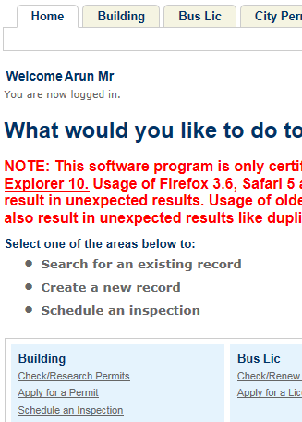

Select ‘Fire’ from the Permit Type Category list | And mark ‘Commercial’ as shown below
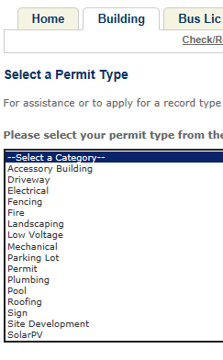 | 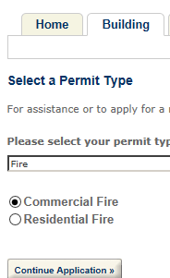

Enter the house number: 76  Enter the direction: W  Enter the Street: 900  For the address  76 South 900 West  And you should get detail as shown.  If correct, then push the [Continue] button. | 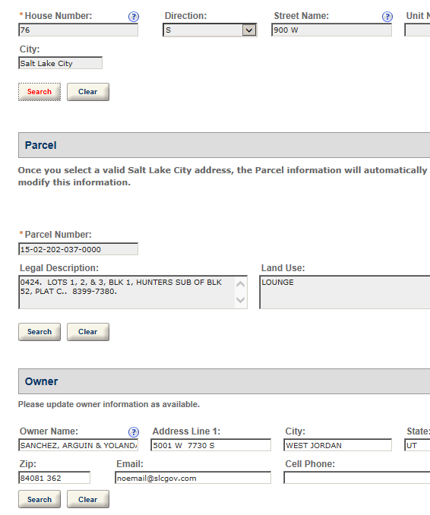

Choose the [Contact Info] in Step 2  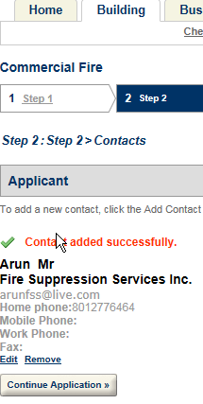 | In Step 3  Use [PROFESSIONAL] * [00 0 00] as the license holder and fill in the contact info  