RFP for private developer at
Your Bid Proposal to be in the following format:

From: Excavating
Division 31 Section 23 00 Trench & Backfill to supply underground utility water to sprinkler riser
Division 33 Section 11 19 Fire Suppression Utility Water Distribution Piping
To:

Bid Proposal

References
NFPA 10: Standard for Portable Fire Extinguishers.
NFPA 13: Installation of Sprinkler Systems.
NFPA 72: National Fire Alarm Code.
NFPA 170: Standard for Fire Safety and Emergency Symbols.
Incorporated into this document are other NFPA Codes as referenced and where applicable.
Ref: http://www.nfpa.org/aboutthecodes/list_of_codes_and_standards.asp
EN 12845: Fixed firefighting systems, Automatic sprinkler systems, Design, installation and maintenance.
International Fire & Building Code/s and Life Safety Code.

Summary
This proposal is to supply an underground FOUR inch Fire Suppressing Sprinkler water line from the Public Utility Water Main, and end with a Riser Flange inside the building at the riser room,

For the building at , building, all levels, in accordance with the above referenced standards where applicable, and in accordance with approved Drawings, Calculations and Permits, and all addendums as released as of 2015-Jan-05

Inclusions
- Construct a FOUR inch line and tie in to Building from [500 East Street] Public Utility Stub to a Flange inside the building.
- Supply cold/hot TAP
- Supply flange
- Cut concrete floor in riser room location inside building for stub and return concrete & hole to clean condition.
- Cast-in-place concrete for use in concrete thrust blocks, valve box and indicator post collars, and other concrete structures required by the contract drawings, shall conform to the requirements of Division 3, Section "Cast-in-Place Concrete".
- Key-valve for shut off at street.
- Extend stub if required [north][south][east][west] beyond, for next building and Cap off.

- While returning soil/gravel to all holes & trenches, soil/gravel will be compacted and compaction tested.
- Return roadway, T-patch asphalt/bitumen, Concrete Sidewalk, curbing and channeling to its original condition or better condition.

- Flush test, Pressure Test, Bacteria test, Chlorination and supply all data and results to Contractor. (Fire Suppression Services Inc.)
- Liaise with City, AHJ and Utilities in order to effect a smooth transition to owner.

- Obtain Permits as necessary.
- Supply Fire Suppression Services with all Permits and Documentation.

Exclusions
- ?
- ?
- ?
//-----------------------------------
Connection Fee and Inspection Fee is how much for FOUR-inch?? Inclusion??
Separate out the cost please in Schedule of Values Break-Out sheet.
//-----------------------------------------------------------------------------------

ITEM-2
Alternate 1 addition if required by AHJ:
Add a fire hydrant & Key valve at xxx street sidewalk or at location required by AHJ.
Total Price: $_________________

Notes to Owner/Architect
No more than one hundred fifty (150) feet of trench shall be left open at any time.
The entire trench shall be backfilled to within fifty (50) feet of the open trench upon conclusion of each day’s WORK.
The trench shall not be backfilled until the pipe installation is found acceptable by ENGINEER.
Trench shall be backfilled within one hundred (100) feet of the pipe installation at all times.
Clean-up shall be maintained within four hundred (400) feet of the trench excavation.
Prior to placement in the trench, all pipes, fittings, and appurtenances shall be cleaned and examined for defects by CONTRACTOR.
If found defective, CONTRACTOR shall reject the defective pipe, fitting, or appurtenance.
CONTRACTOR shall advise ENGINEER of all defective materials.

Surplus Excavation:
All surplus excavation shall be placed, in an orderly manner.
If material is stockpiled on private property, written permission shall be obtained from the property owner and provided to ENGINEER.
//-------------------------------------------------------------------------------------
Regards

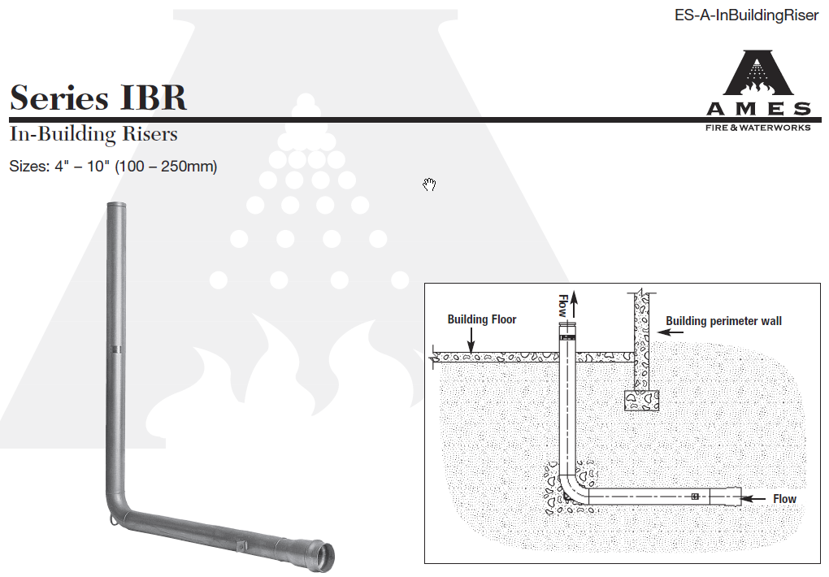
18” min
