To: Whom it may concern

From: Fire Suppression Services Inc.
Division 31 Section 23 00 Trench & Backfill to supply underground utility water to sprinkler riser
Division 33 Section 11 19 Fire Suppression Utility Water Distribution Piping

Bid Proposal

References
NFPA 10: Standard for Portable Fire Extinguishers.
NFPA 13: Installation of Sprinkler Systems.
NFPA 14: Installation of Standpipe & Hose Systems
NFPA 24: Installation of Private Service Fire Mains & Appurtenances
NFPA 72: National Fire Alarm Code.
NFPA 170: Standard for Fire Safety and Emergency Symbols.
Incorporated into this document are other NFPA Codes as referenced and where applicable.
Ref: http://www.nfpa.org/aboutthecodes/list_of_codes_and_standards.asp
EN 12845: Fixed firefighting systems, Automatic sprinkler systems, Design, installation and maintenance.
International Fire & Building Code/s and Life Safety Code.

Summary
This proposal is to supply an underground SIX inch Fire Suppressing Sprinkler water line from the Public Utility Water Main, and end with a Riser Flange inside the building at the riser room, (location to be determined); for the ….. Enter name and address of job here …… building, in accordance with the above referenced standards where applicable, and in accordance with approved Drawings, Calculations and Permits, and all addendums as released as of 2017-Jan-16

Inclusions
- Construction of a SIX inch line and tie in to Building from Private Service main Utility Stub to a Flange inside the building. (approx. run across the ‘lot’ is 270 feet)
- Road Cut Permits only
- Supply cold/hot TAP as needed.
- Supply flange (IBR)
- Where applicable, cut concrete floor in riser room (to be built by others) inside building for stub and return concrete & hole to clean condition.
- Key-valve for shut off at street at or near the tap.
- Extend stub, if required by AHJ, beyond utility mains, for next building and Cap off.
- While returning soil/gravel to all holes & trenches, soil/gravel will be compacted.
  - Compaction testing is To Be Done by Others.
- Return roadway, asphalt/bitumen, concrete sidewalk, curbing and channeling to its original or better condition.
- Perform: Flush test, Pressure Test, Bacteria test, Chlorination and supply all data and results to the Contractors PM at Fire Suppression Services Inc.
- Liaise with City, AHJ and Utilities in order to effect a smooth transition to owner.
- If they are required in this jurisdiction, obtain Permits as necessary.
- Supply Fire Suppression Services with all Permits, test results and Documentation.

Exclusions
- If not noted/listed as an inclusion in the above list it is excluded, and cause additional charges to you.
- Note: Item 8) above regarding Compaction testing:
  - Is To Be Done by Others, not done by FSS or our underground technicians.
- Connection Fee’s
- Inspection Fee’s, and all other fees
- Owner must:
  - Obtain Permits with their city, and cover all their City’s requirements, and
  - Pay all utility reconnection fees.

Notes to Owner/Architect
- Blue Stakes will need a minimum of two days’ notice. (Ordinance)
- City & Local Permitting may take up to four days.
- It is possible to put down a concrete pour leaving a five-foot by five-foot un-concreted square, where the SIX inch riser comes up through the floor.
- Riser flange cannot be greater than ten feet from the outside wall. (Code)
- You will need to include a riser room in your design. Room must:
  - Be heated & maintained above 40℉ at all times and lit. (Code)
  - Must have a minimum of one 110-125 VAC 20 Amp dedicated grounded outlet.
  - Outside door (To Be Done by Others) to the riser room must include a ‘Riser Room’ label on its exterior side. Put it in the Sprinkler Scope. (Div-21) (Code)
  - Protect riser equipment and valves from damage & tampering.
- No more than one hundred fifty (150) feet of trench shall be left open at any time.
- The entire trench shall be backfilled to within fifty (50) feet of the open trench upon conclusion of each day’s work.
- The trench shall not be backfilled until the pipe installation is found acceptable by engineering group.
- Trench shall be backfilled within one hundred (100) feet of the pipe installation at all times.
- Clean-up shall be maintained within four hundred (400) feet of the trench excavation.
- Prior to placement in the trench, all pipes, fittings, and appurtenances shall be cleaned and examined for defects by contractor & Fire Suppression Services Technicians (CONTRACTOR).
- If found defective, CONTRACTOR shall reject the defective pipe, fitting, or appurtenance.
- CONTRACTOR shall advise ENGINEER of all defective materials.
- Surplus Excavation:
  - All surplus excavation shall be placed, in an orderly manner.
  - If material is stockpiled on private property, written permission shall be obtained from the property owner and provided to ENGINEER or FSS.
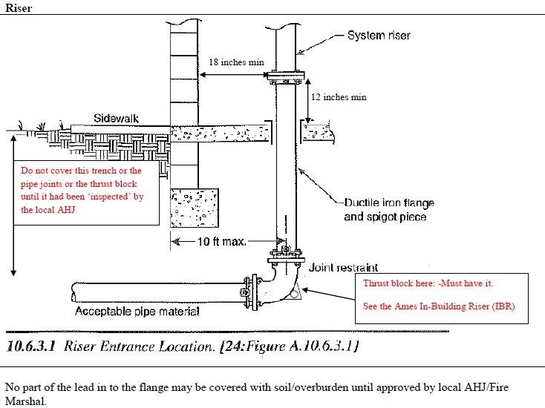
- All trenching and pipe-work has to remain uncovered for inspection.
- The thrust block must remain uncovered for inspection. (Code)
- Flush test and water running clear must be observed by AHJ before Riser installed on IBR flange. (Code)
- Bacteria test also required. (Code)
- You may use EITHER: a Grooved OR: a Flanged termination in the riser room, on the IBR. Check with AHJ first.
- Riser area pipe-work has to be minimum of one-foot six inches (18”) away from any exterior wall.
- Cast-in-place concrete for use in concrete thrust blocks, valve box and indicator post collars, and other concrete structures required by the contract drawings, shall conform to the requirements of Division 3, Section "Cast-in-Place Concrete".

Additional Charges
If required by AHJ, an additional charge will apply to add a fire hydrant at or near the connection to the main, or the street sidewalk or at location required by AHJ.
If required by Local Ordinances, Flaggers will be supplied at additional cost to Owner

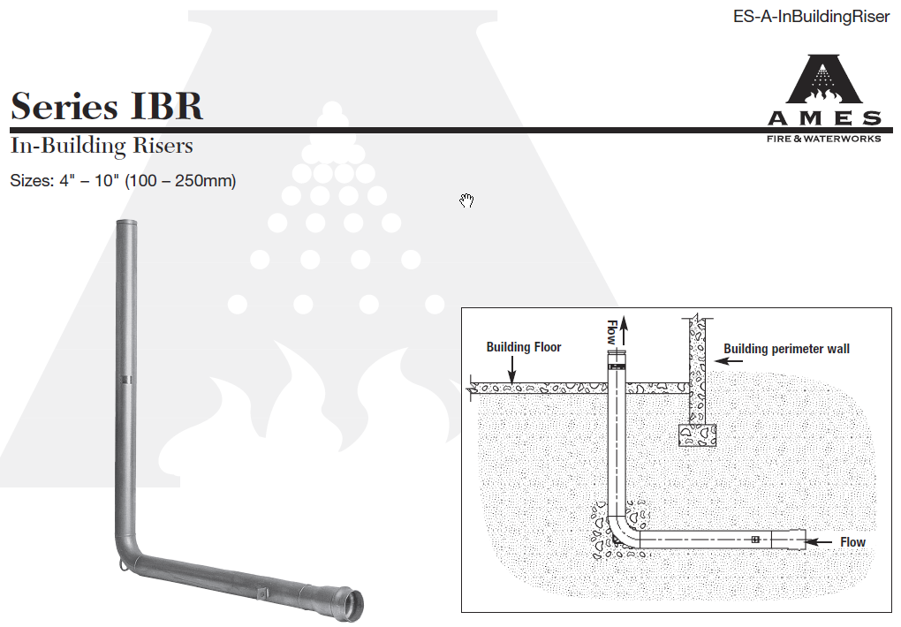
And door in to Riser room
18” min
Note that many Jurisdictions do not allow a Groove end, and may insist on Flange end. Check with AHJ
Vertical & Horizontal pipework MUST be anchored back to Block to hold EL seal.

Addenda

BOND (ADDITIONAL CHARGE)
If requested, Fire Suppression Services Inc. shall furnish Bonds in the form requested by you, the 'Owner', covering the faithful performance of the Agreement, and the payment of all obligations arising there under. These may be in the form of 100% Performance, 100% Labor and Material Payment, and Lien Bonds.

The FULL cost of providing such Bond/s for you, the Owner and/or his Agent/Contractor shall be paid by you, the Owner/Agent/Contractor or whosoever may require Fire Suppression Services Inc. to furnish said Bond/s, and is an additional cost/amount, and IS NOT included in this bid.

Any and all payments required by Fire Suppression Services Inc. for the above shall be shown on any Breakout Sheet (e.g.: AIA-G703) as a SEPARATE item list and shall NOT be subject to any “retainage”.
This Subcontractor shall be reimbursed, without any retainage, for the cost of any required performance or payment bonds simultaneously with the FIRST progress payment.

CHANGES, CCO & PCO
All fire sprinkler nozzles and/or pipe-work AND All Hood Systems and their Suppression devices
AND: All Chemical Suppression Systems AND Portable Extinguishers AND: All Alarm Systems, & Underground work, will be installed as per approved Plans; Any change or deviations from said Plans will not be done without approved Change Order/s with attendant cost adjustments.

CONTRACT
Seller objects to modifications and additions to any of the terms of this document, irrespective of the wording of the Purchasers acceptance, or other Purchaser Forms, Documents or hand written annotations on this Document.

FREIGHT
All goods that attract freight are FOB Origin FC.

LABOR
Labor is calculated at a regular day rate and will be performed during business hours. (08:00-16:30) or (07:00-15:30)

MOBILIZATION-DEMOBILIZATION-REMOBILIZATION
If Fire Suppression Services Inc. or its subcontractors have to suspend work, for any reason, and have to demobilize before completion, then we are entitled to recover our demobilization costs from you; and, if Fire Suppression Services Inc. and/or its subcontractors have to remobilize we are entitled to recover the remobilization costs from you.

PERMIT, DESIGNS and SUBMITTALS
Any and all payments required by Fire Suppression Service Inc. for Permit, Designs & Submittals shall be shown on any Breakout Sheet (e.g.: AIA-G703) as a SEPARATE item list and shall NOT be subject to any “retainage”. Progress payment applications will be made by G702/703 or by Invoice only.

Prices & Taxes
If Seller is required to pay any taxes or other fees relating to the services to be performed or to the production, sale or transportation of goods, Purchaser will reimburse the Seller for any such taxes or fees. Portable Fire Extinguishers attract Utah Sales Tax.

Tamper
Tampering or Adjusting or Working on Fire Suppression installed and tagged Systems by anyone other than Fire Suppressions Authorized personnel or Certified /Authorized / Licensed Fire Protection Service Personnel not only jeopardizes the safe and correct operation of the equipment; it voids the tags on said System, voids all FSS Warrantees, and it is highly likely it will affect your Insurance.
Unless your maintenance department personnel are so authorized, it is advisable to leave the System equipment maintenance and servicing to Certified Personnel.

Right of Way
Fire Suppression Services requires first right of way; this means that Fire Suppression Sprinkler Technician/Fitters “must be First & High”.

Asbestos Notice:
FIRE SUPPRESSION SERVICES Inc. IS NEITHER FORMALLY LICENSED IN THE REMOVAL OF, NOR THE ANALYSIS OF ASBESTOS. OUR COMPANY WILL THEREFORE NOT NORMALLY DEAL WITH ALL ASBESTOS RELATED INCIDENTS IN A PRACTICAL SENSE ON BEHALF OF OUR CLIENTS. WHEN THE PRESENCE OF ASBESTOS IS SUSPECTED WE WILL STOP WORK AND APPOINT COMPETENT AND ACCREDITED SUB CONTRACTORS ON A SITE-SPECIFIC BASIS TO CARRY OUT ANY REMOVALS OR TEST

