If an accelerator is fitted, a TANK mounted Compressor is required. It must have its OWN AMD on the tank, in addition to the 757. This Compressor must be mounted on Vibration Isolation Pads: General Air KVP4x4.
As seen at FF&FAB  757 AMD Trim assembly.  Low Press Actuator.  776-LPA  746-LPA LP Accelerator is not shown | 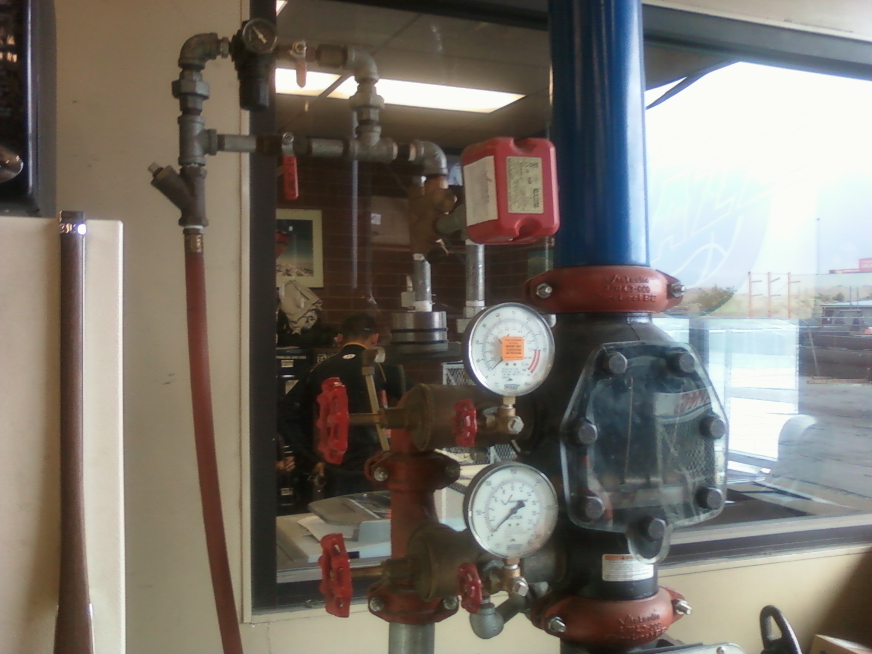
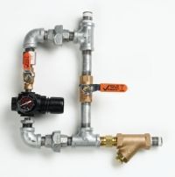 |  | 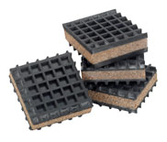
I believe the 757 should be set to 13 psi |  | General Air KVP4x4 Vibration Isolation.
Below is not for GENERAL copy it was refering to another job.
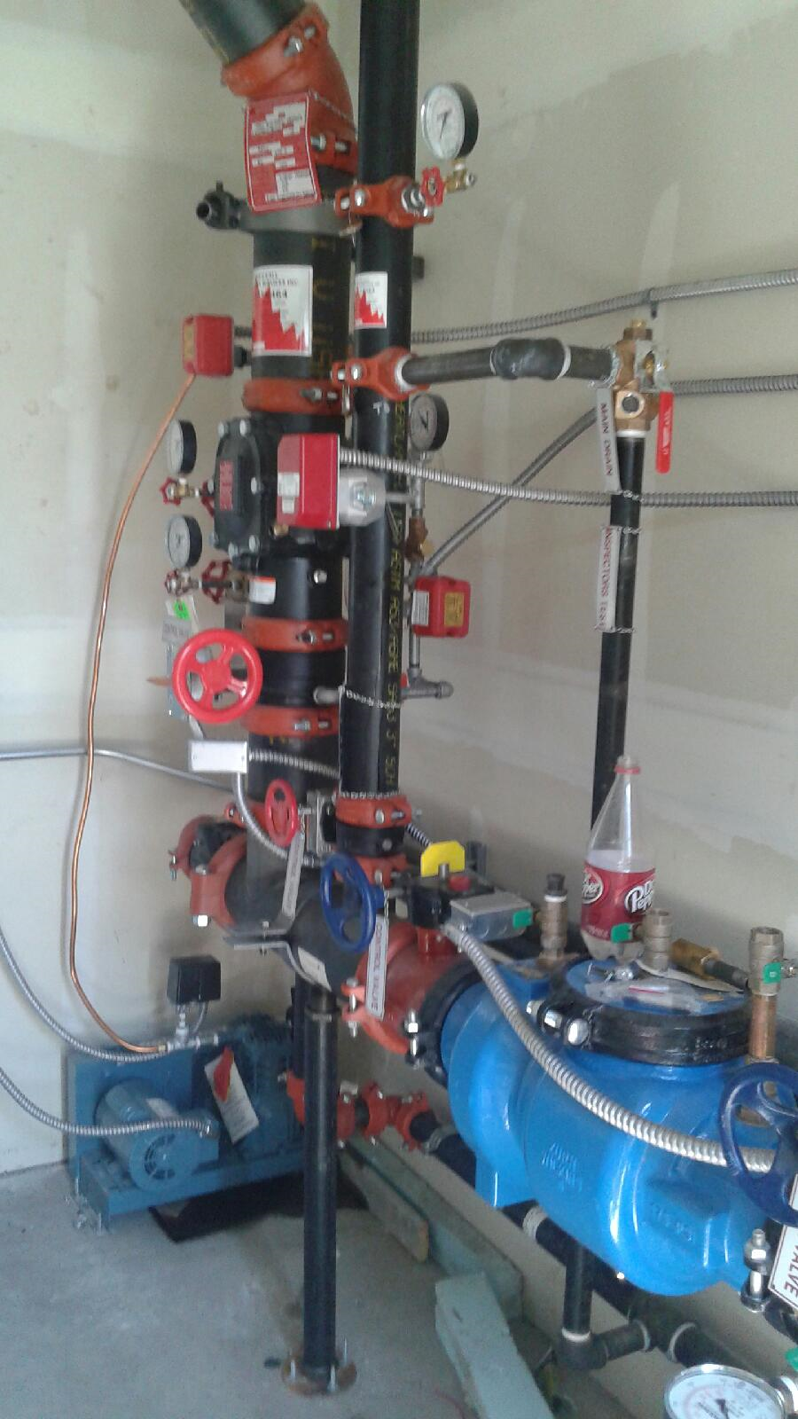 |  | Flwx Pipe that is supplied with the GenAir Compressor, is required between HARD pipe and the Tank.  P3002MP 30” or P1202MP 12”  Stainless Flex-Hose  