The “drum drip” is an auxiliary drain for dry pipe and pre-action systems in areas subject to freezing.
These units are required for sections of trapped piping where five or more gallons of water may be trapped.
ALL SPACES that contain WATER FILLED wet suppression systems MUST BE KEPT ABOVE 40 degrees F. (4 degrees C) (INCLUDES TENTED SPACE AND STAIRWELLS)

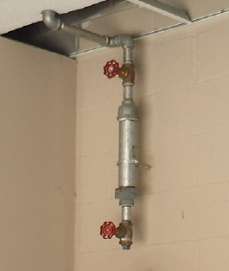 | 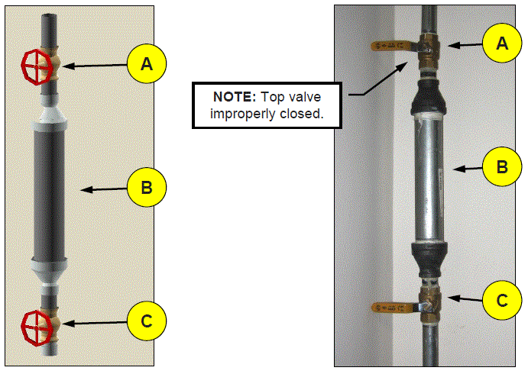

You may have multiple drum-drips at your site.
ALL DRUM DRIPS MUST BE DRAINED ROUTINELY DURING FALL AND WINTER MONTHS, EVEN WHEN
WATER IS NOT FOUND ON A REGUAR BASIS. SET UP a LOG SHEET TO MONITOR DRAIN SIGN OFF

Water that has entered the system, either because the valve has tripped or from condensation of moisture from the pressurized air in the system, must be regularly drained from the Drum to prevent freezing.

The 2” x 12” condensate nipple (B) allows for the collection and removal of water and moisture from
the system without allowing system air loss that may inadvertently trip (operate) the dry or
pre-action valve.

When a drum drip is in “normal” position, the top 1” valve (A) is open, allowing moisture to enter
the condensate nipple, while the bottom 1” valve (C) is closed.

To drain the condensate nipple, the top valve (A) is closed then the bottom valve (C) is opened to remove accumulated moisture. NEVER open both valves at the same time! (You will ‘trip’ open, the main system valve in the riser room)

It is preferable to locate the drum drip in a heated area. However, it is not always possible to accomplish this; therefore, you might find a drum drip located in areas subject to freezing.
This will put an additional responsibility on the user of the system to keep the drum drip properly drained during the freezing seasons.

