The Wilkins Reduced Pressure Back Flow that is in the yard ‘appears’ to be supplied from a take-off on the inlet side of the riser stack.

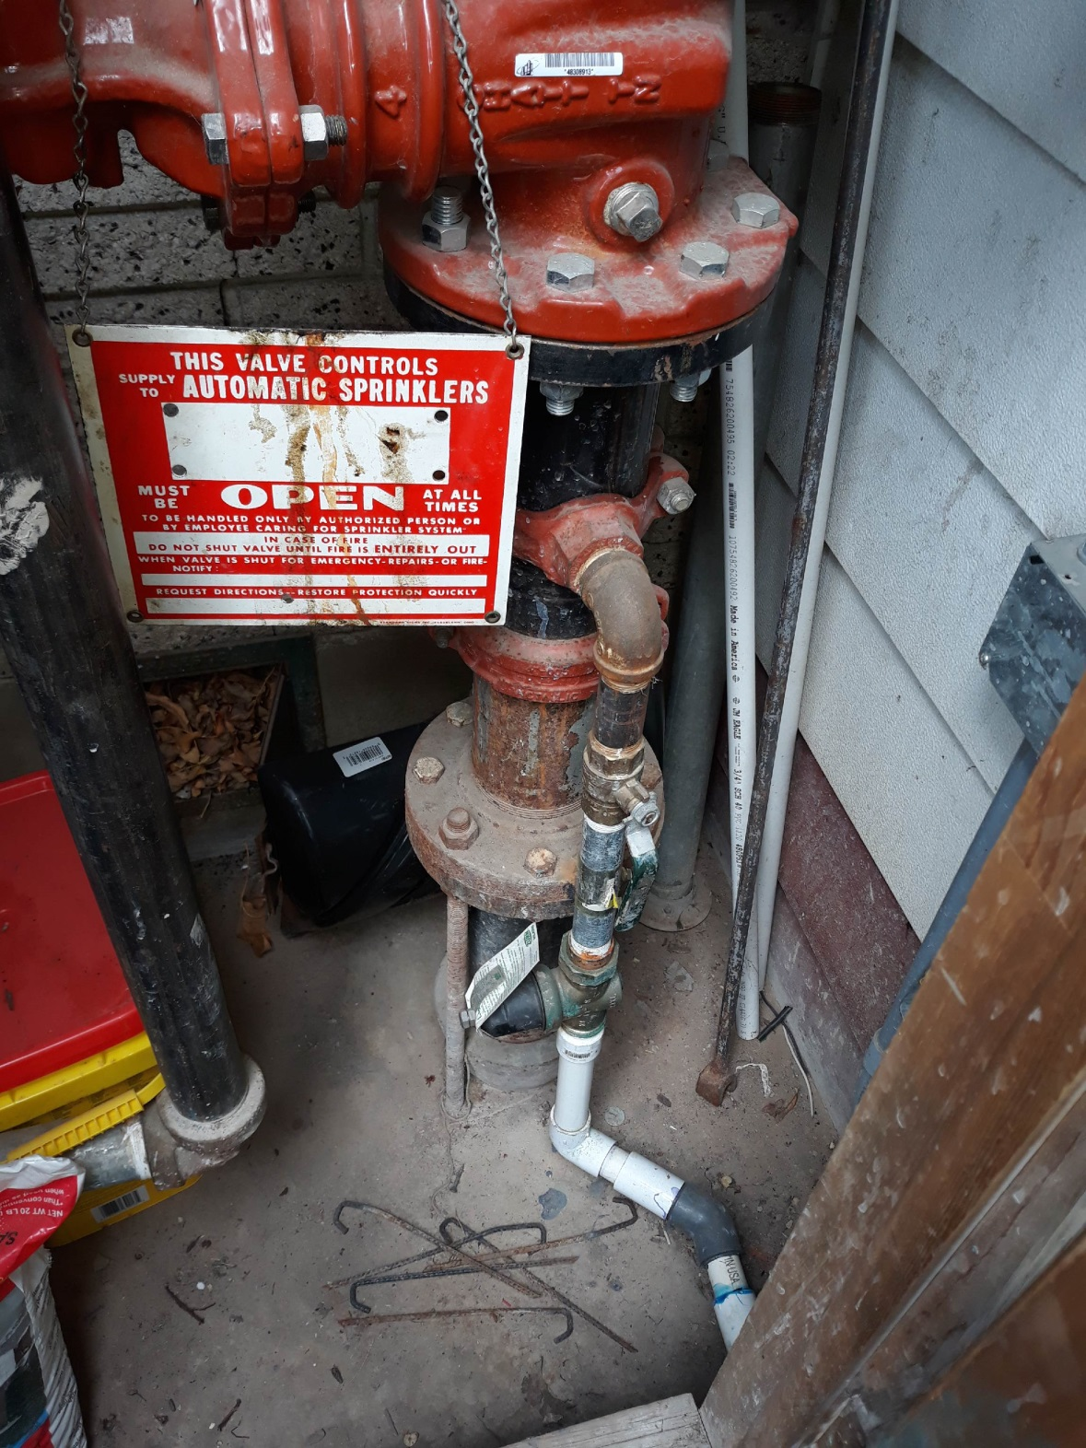
Note:
- There is no Back Flow Preventer on the riser flange before the valve stack.
- There is a mech-T take-off to the lawn irrigation system via a Wilkins 5-75PRV
4” OS&Y

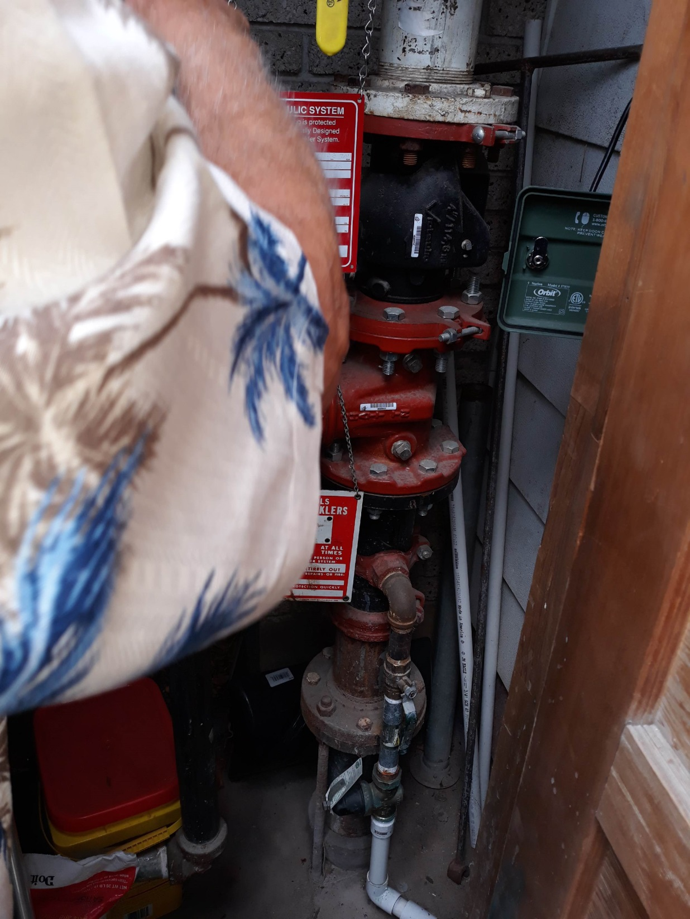
Confirmed: This line goes to outside lawn irrigation sprinks.
Is this line metered? Utility water bypassing meters.
Wilkins 50-75psi PRV
Victaulic 4” grooved
Orbit lawn sprinkler controller
Data required: need clear ‘Calc’ card photos
PVC line from Fire Riser to Lawn sprinks
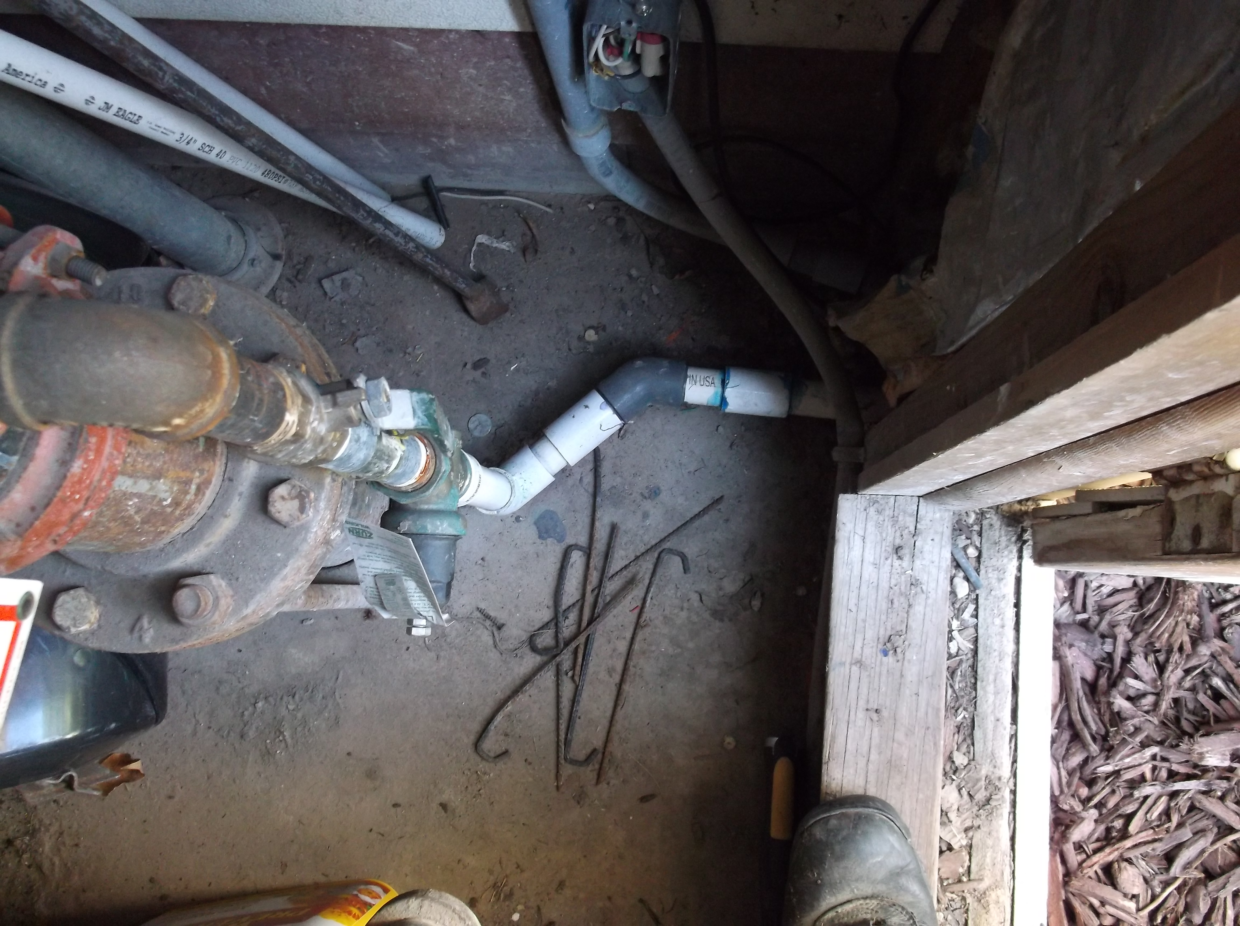
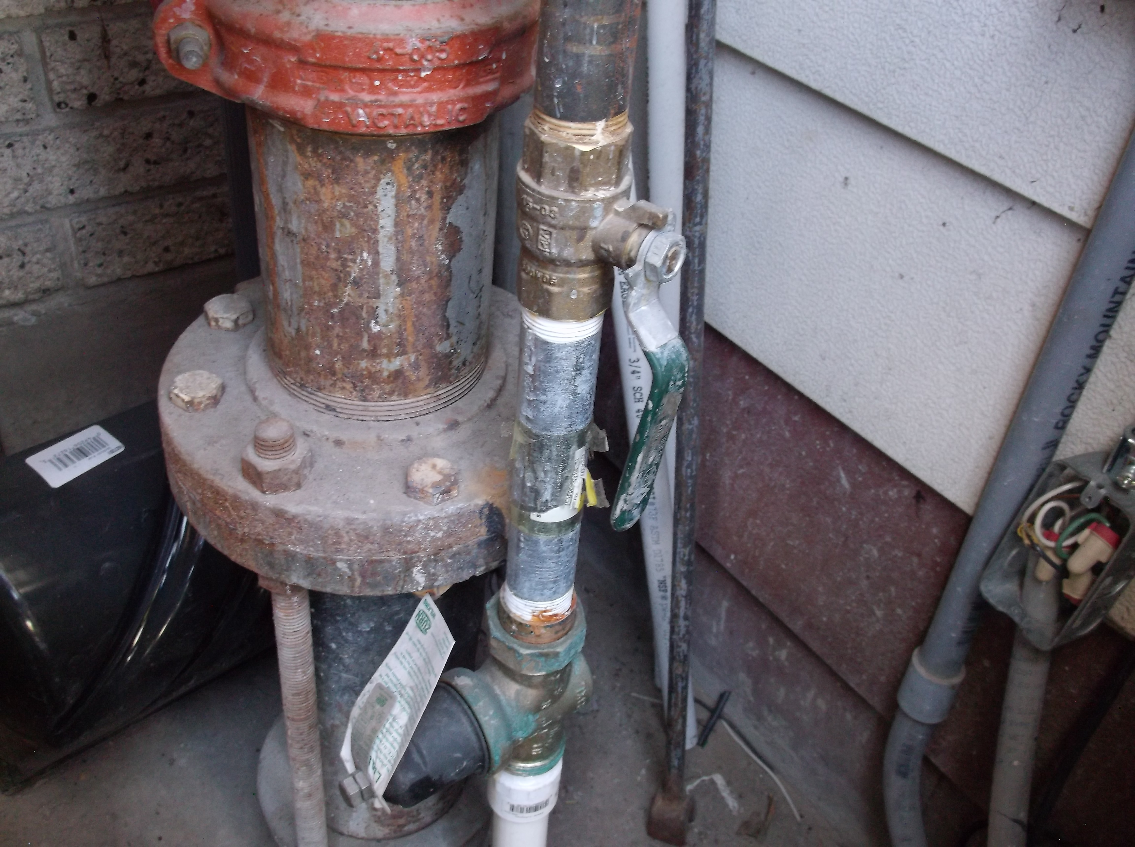

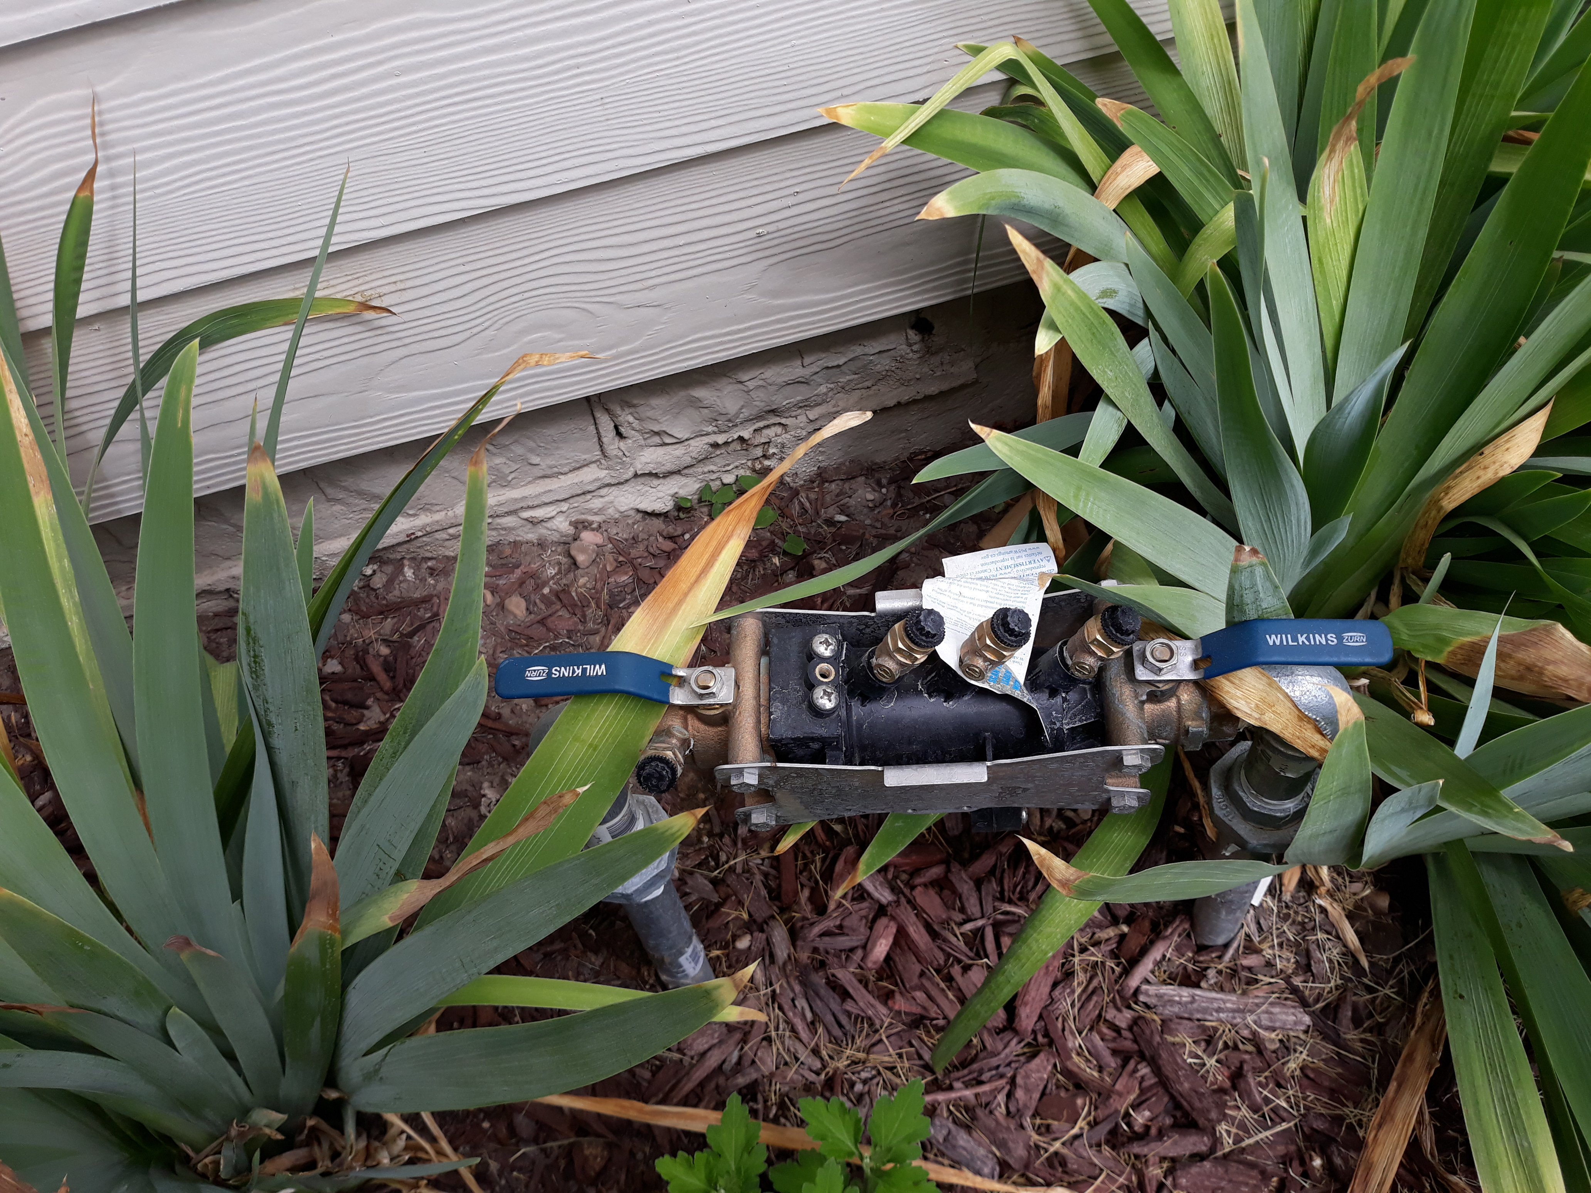 | The lawn sprinkler Zurn-Wilkins model 375 RP, “appears” to be supplied via a tap-off from the fire suppression riser stack.  Please investigate.
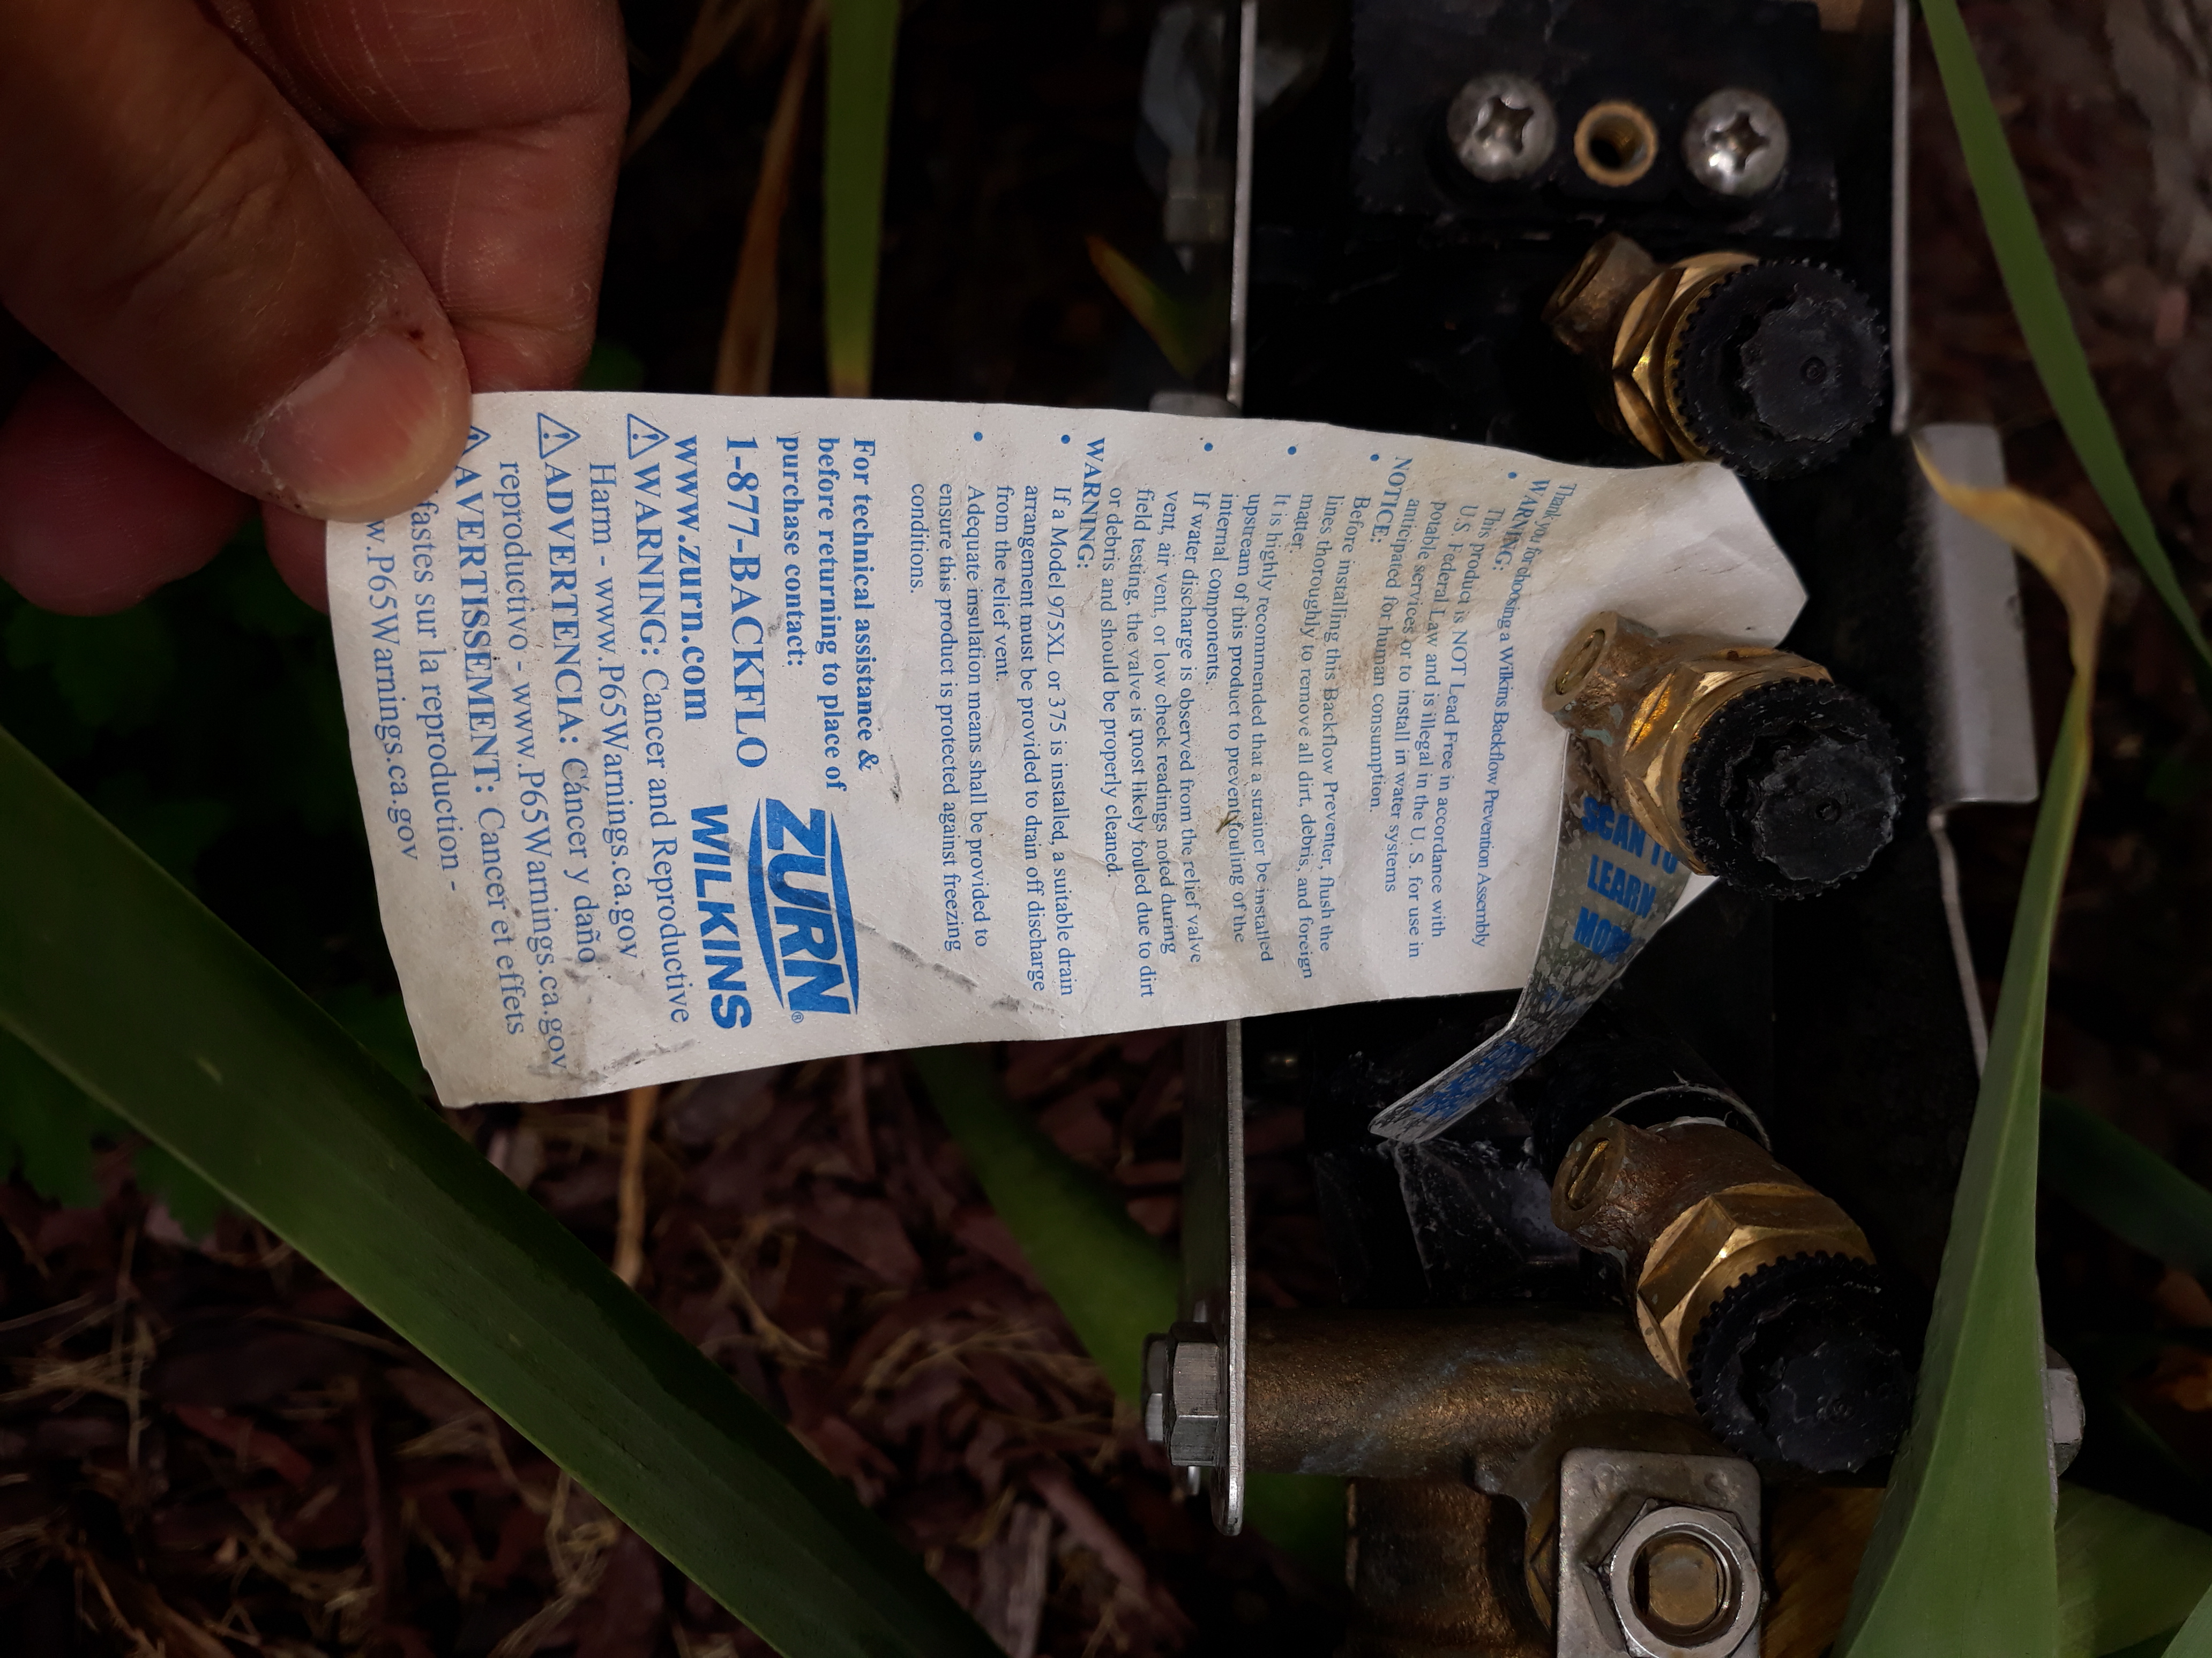
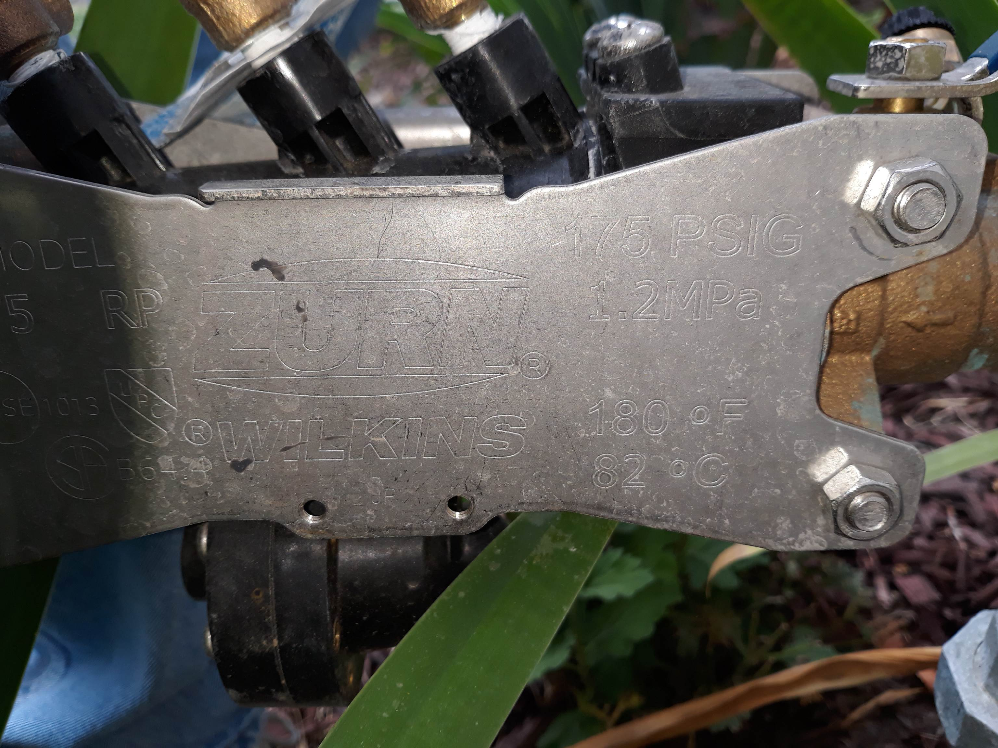

This may be a Code violation.

