Hydrant distances from FDC?
No riser door signs. IS riser room lit, and heated?
Alarm panel and ?annunciator?
Antifreeze system has had additions to it. 2022 limit per State Fire Marshal, along with: this is a Care Center, will prohibit the permissibility of an extension. Additions and alterations to this building may require site brought up to current Code.
Tap off the fire system water supply is not permitted. See Public Utilities water. (metering)
See Code re: riser water supply to irrigation.

Calc Card. 2011 by State Fire for Art city Nursing
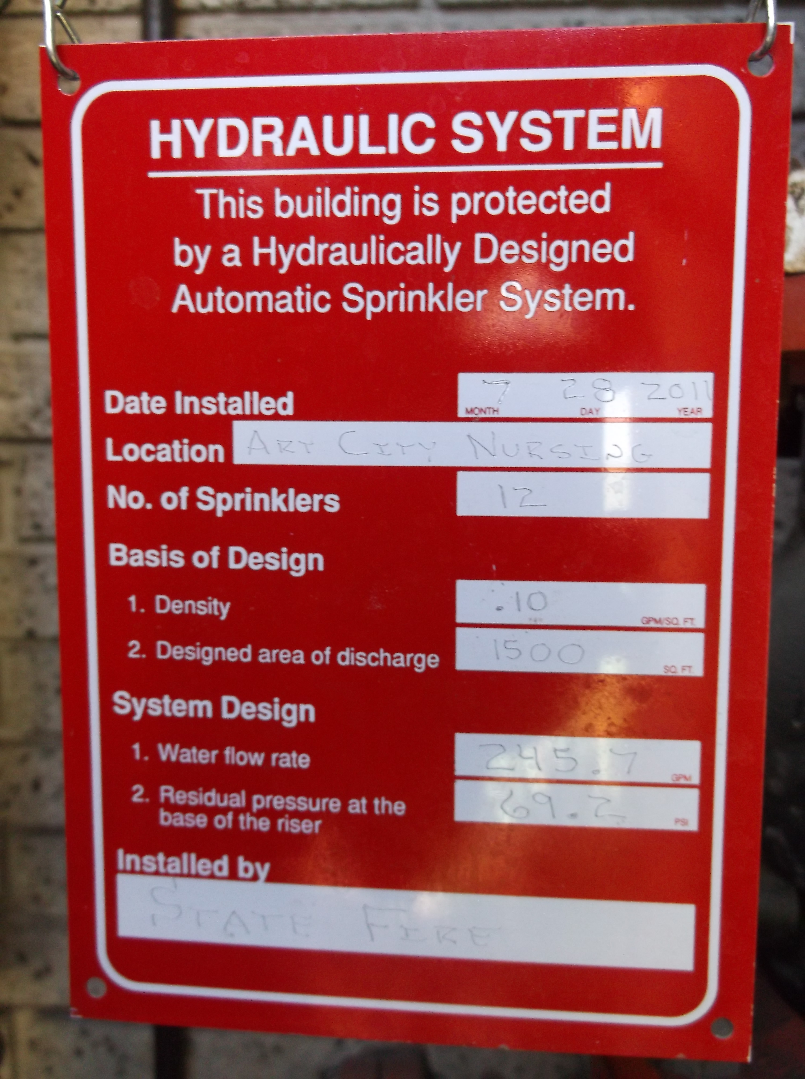

These were observed 2019-08-29
Antifreeze: Top of loop
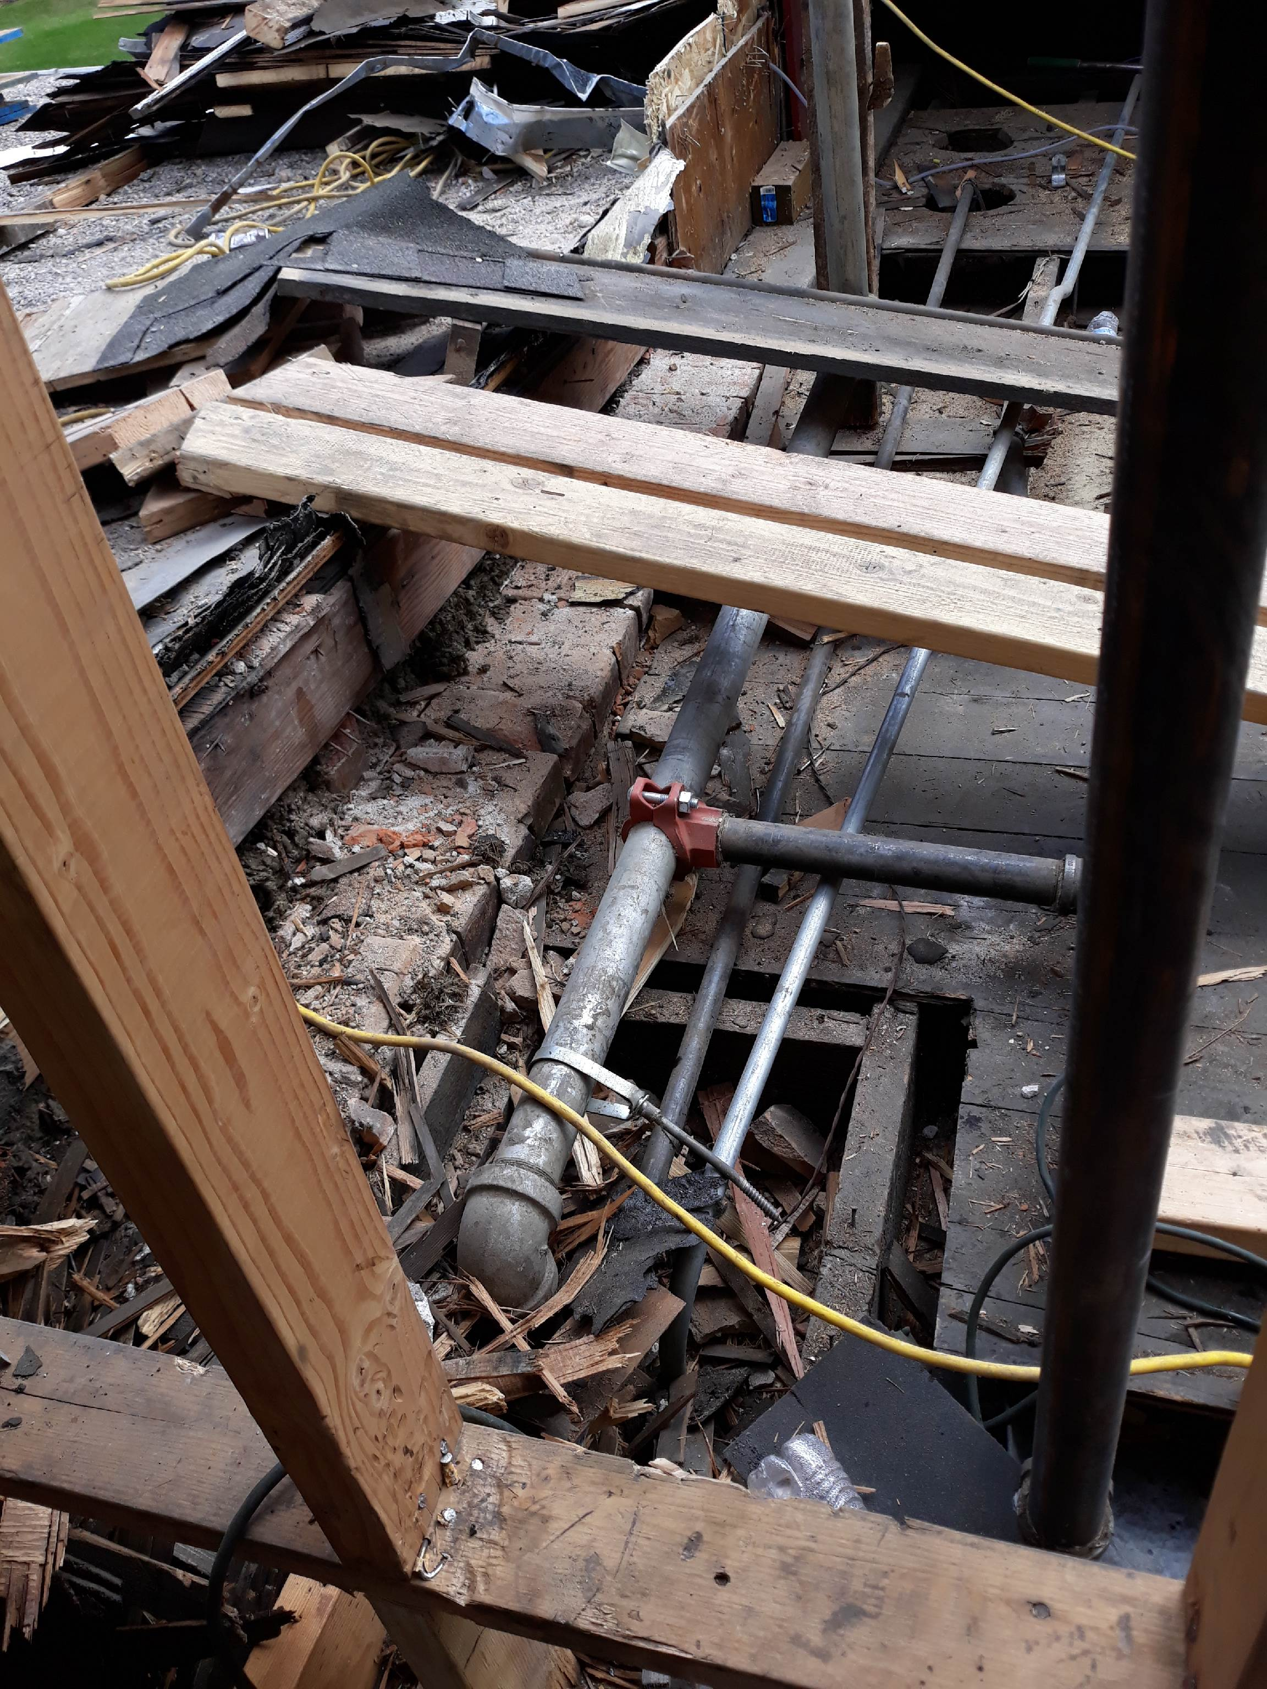

Antifreeze loop: top of closet to ceiling above
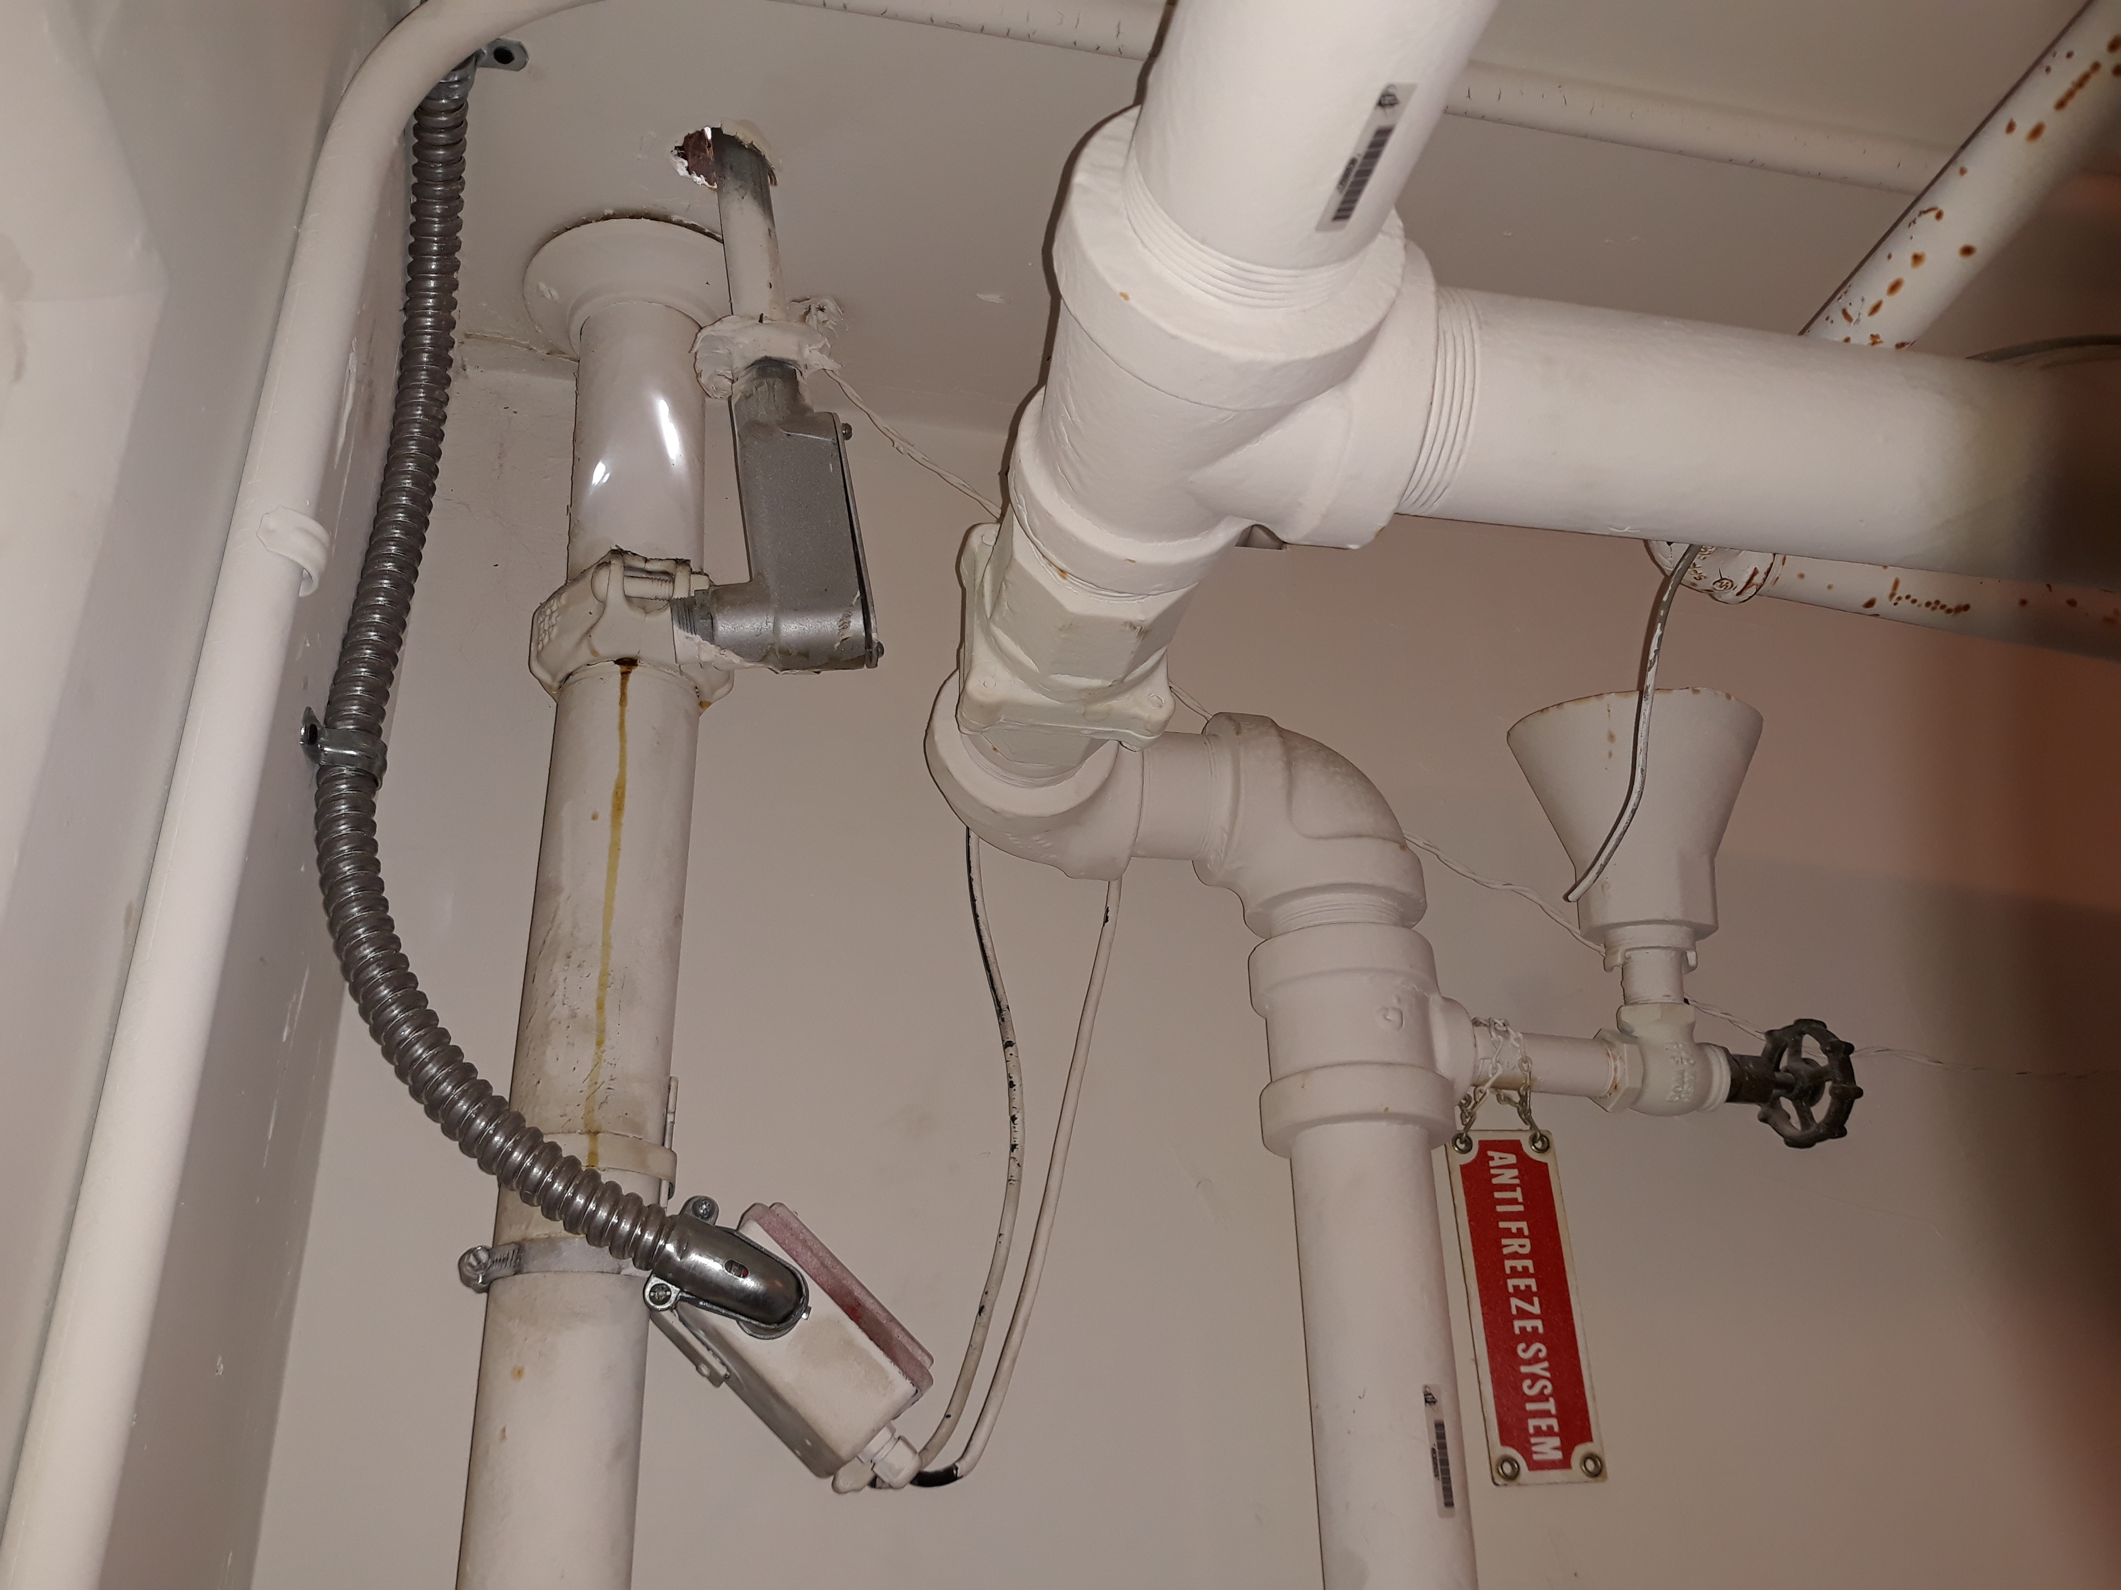

Antifreeze loop mid

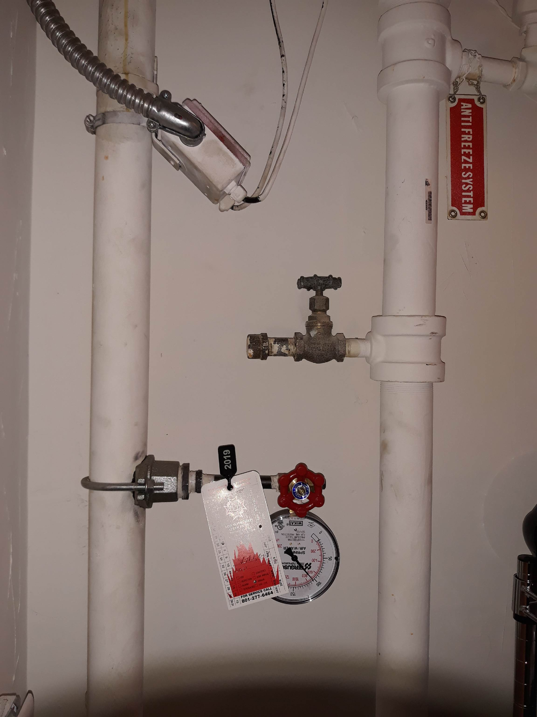

Antifreeze loop bottom of loop
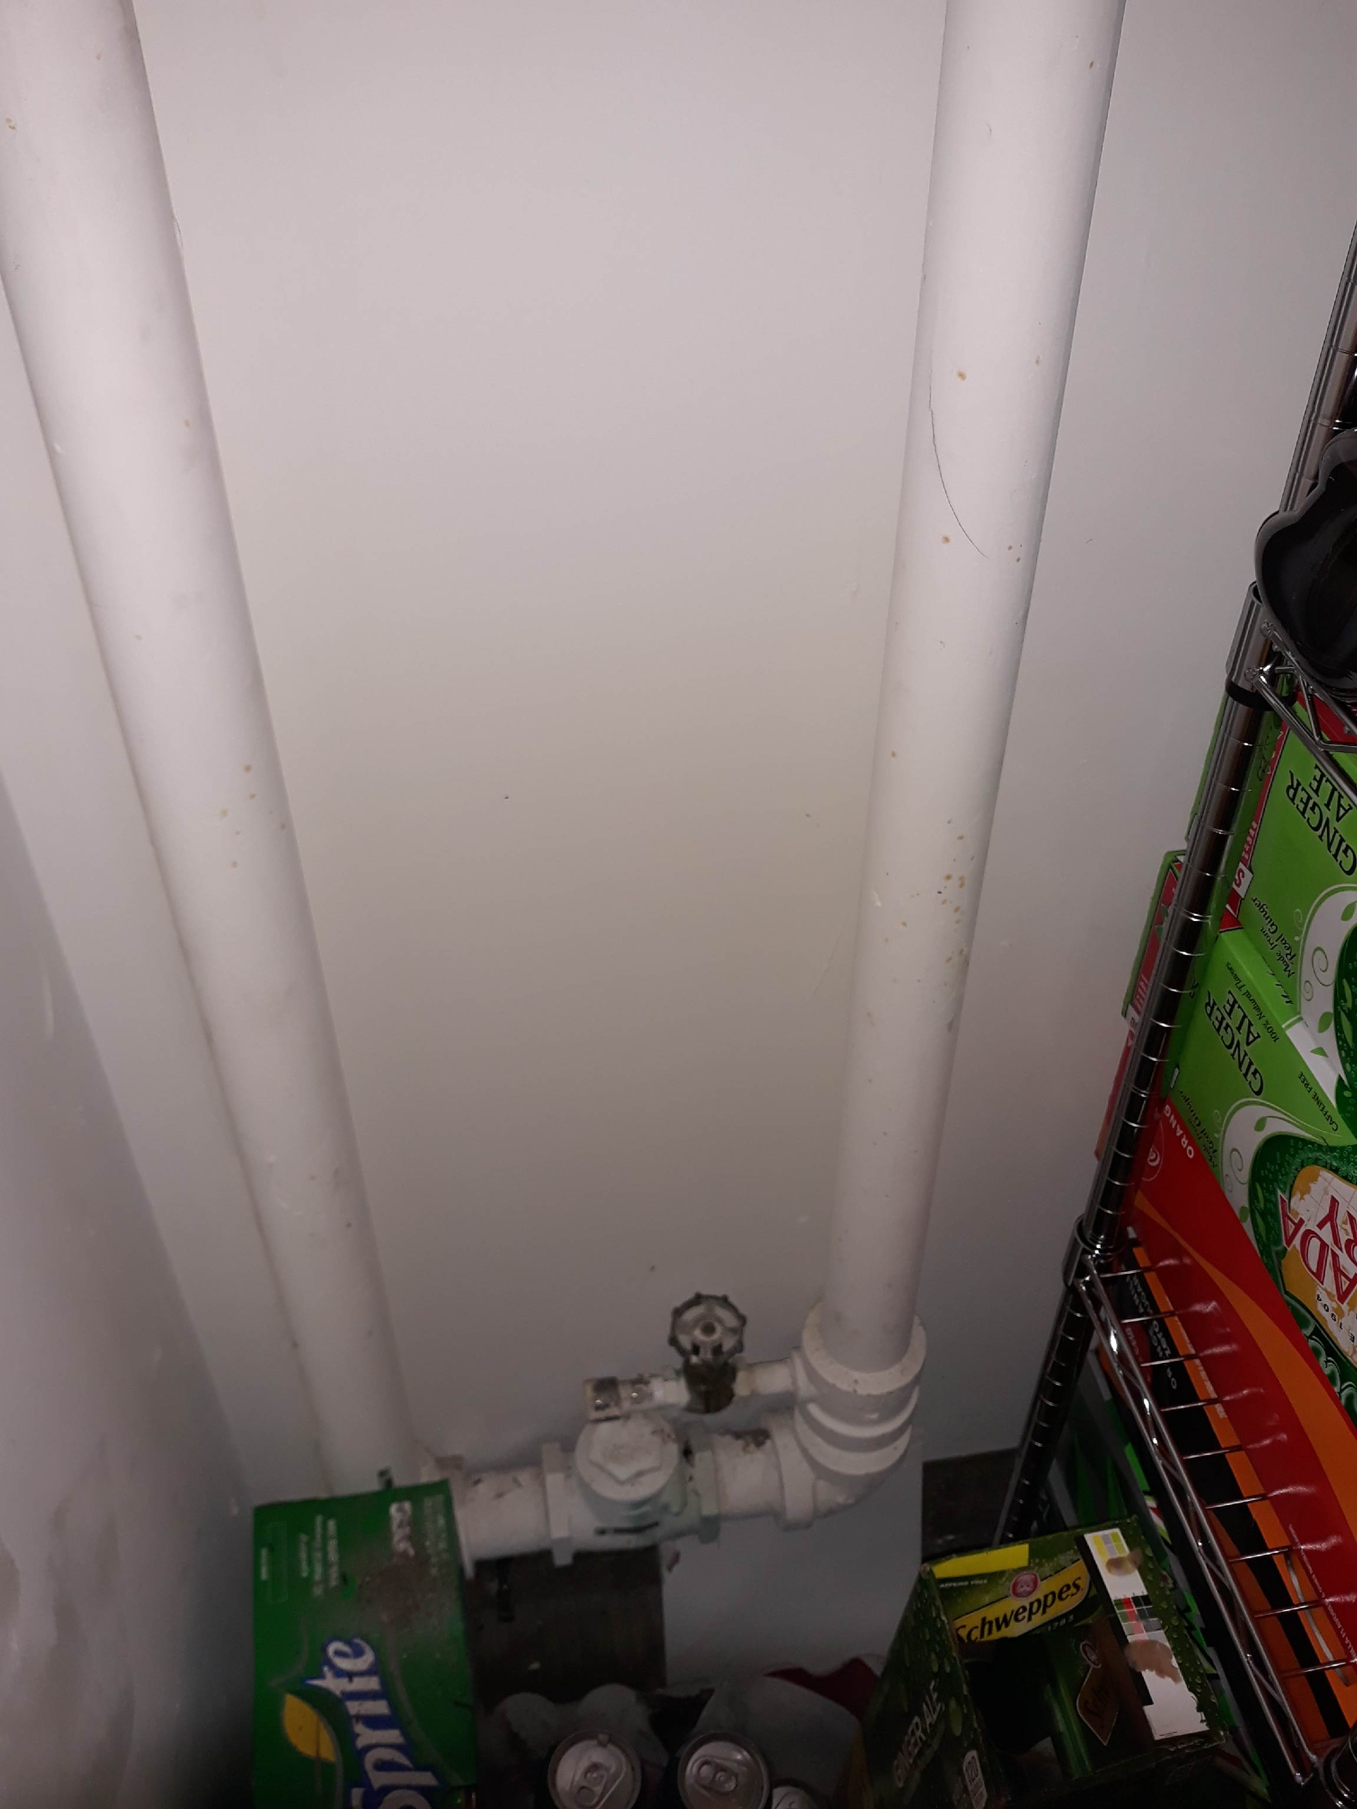

Antifreeze addition in attic with workers as at 2019-08-20
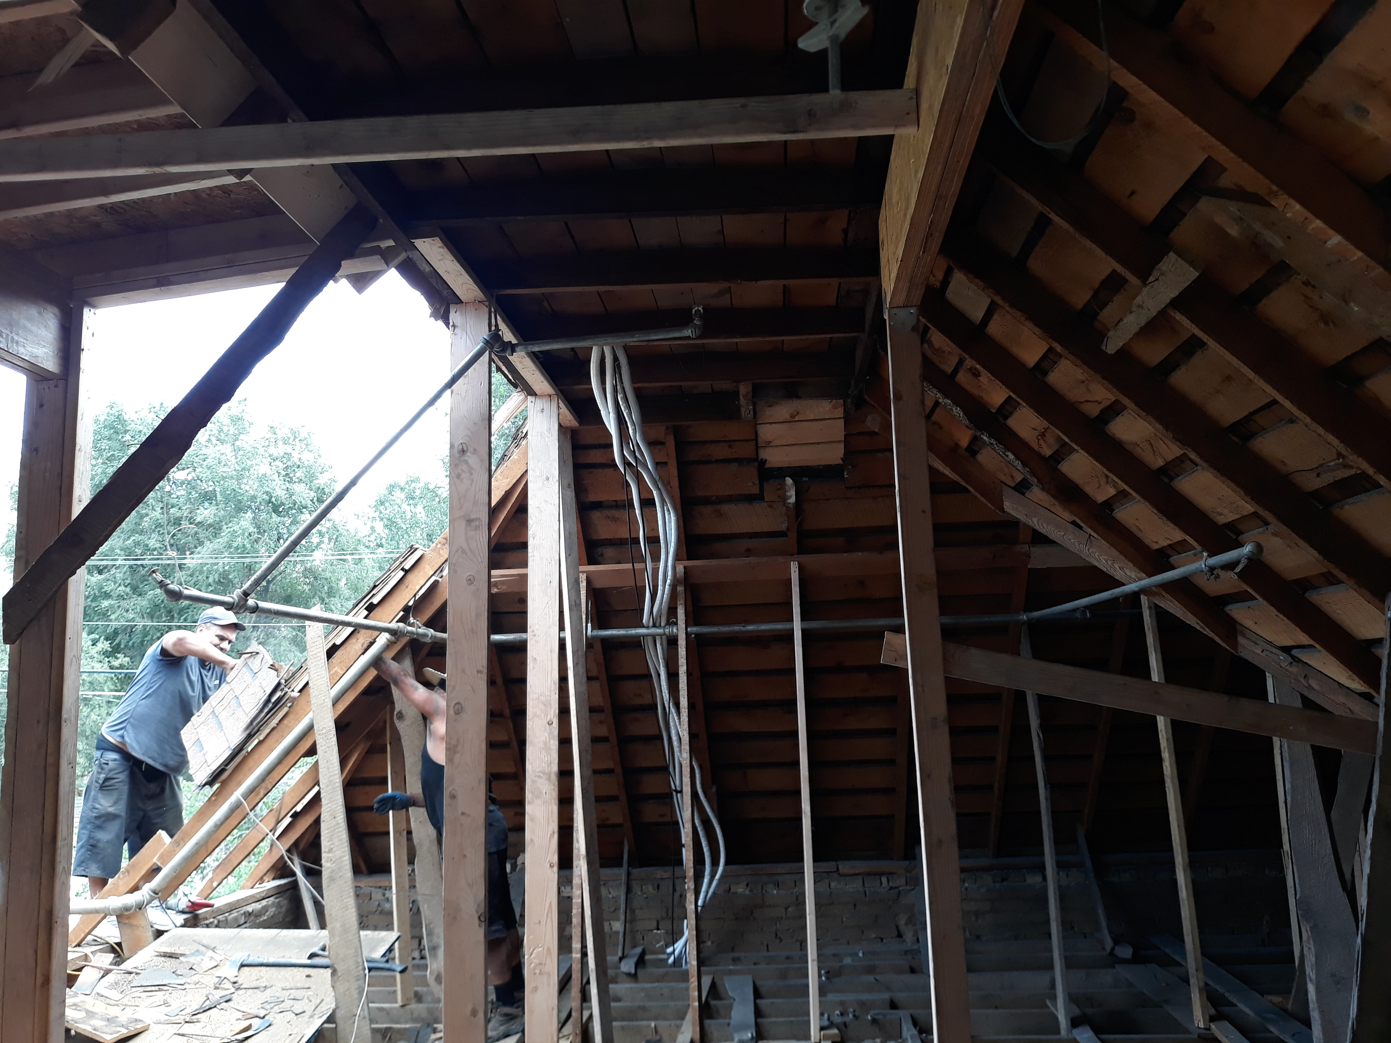

Stop work order on door

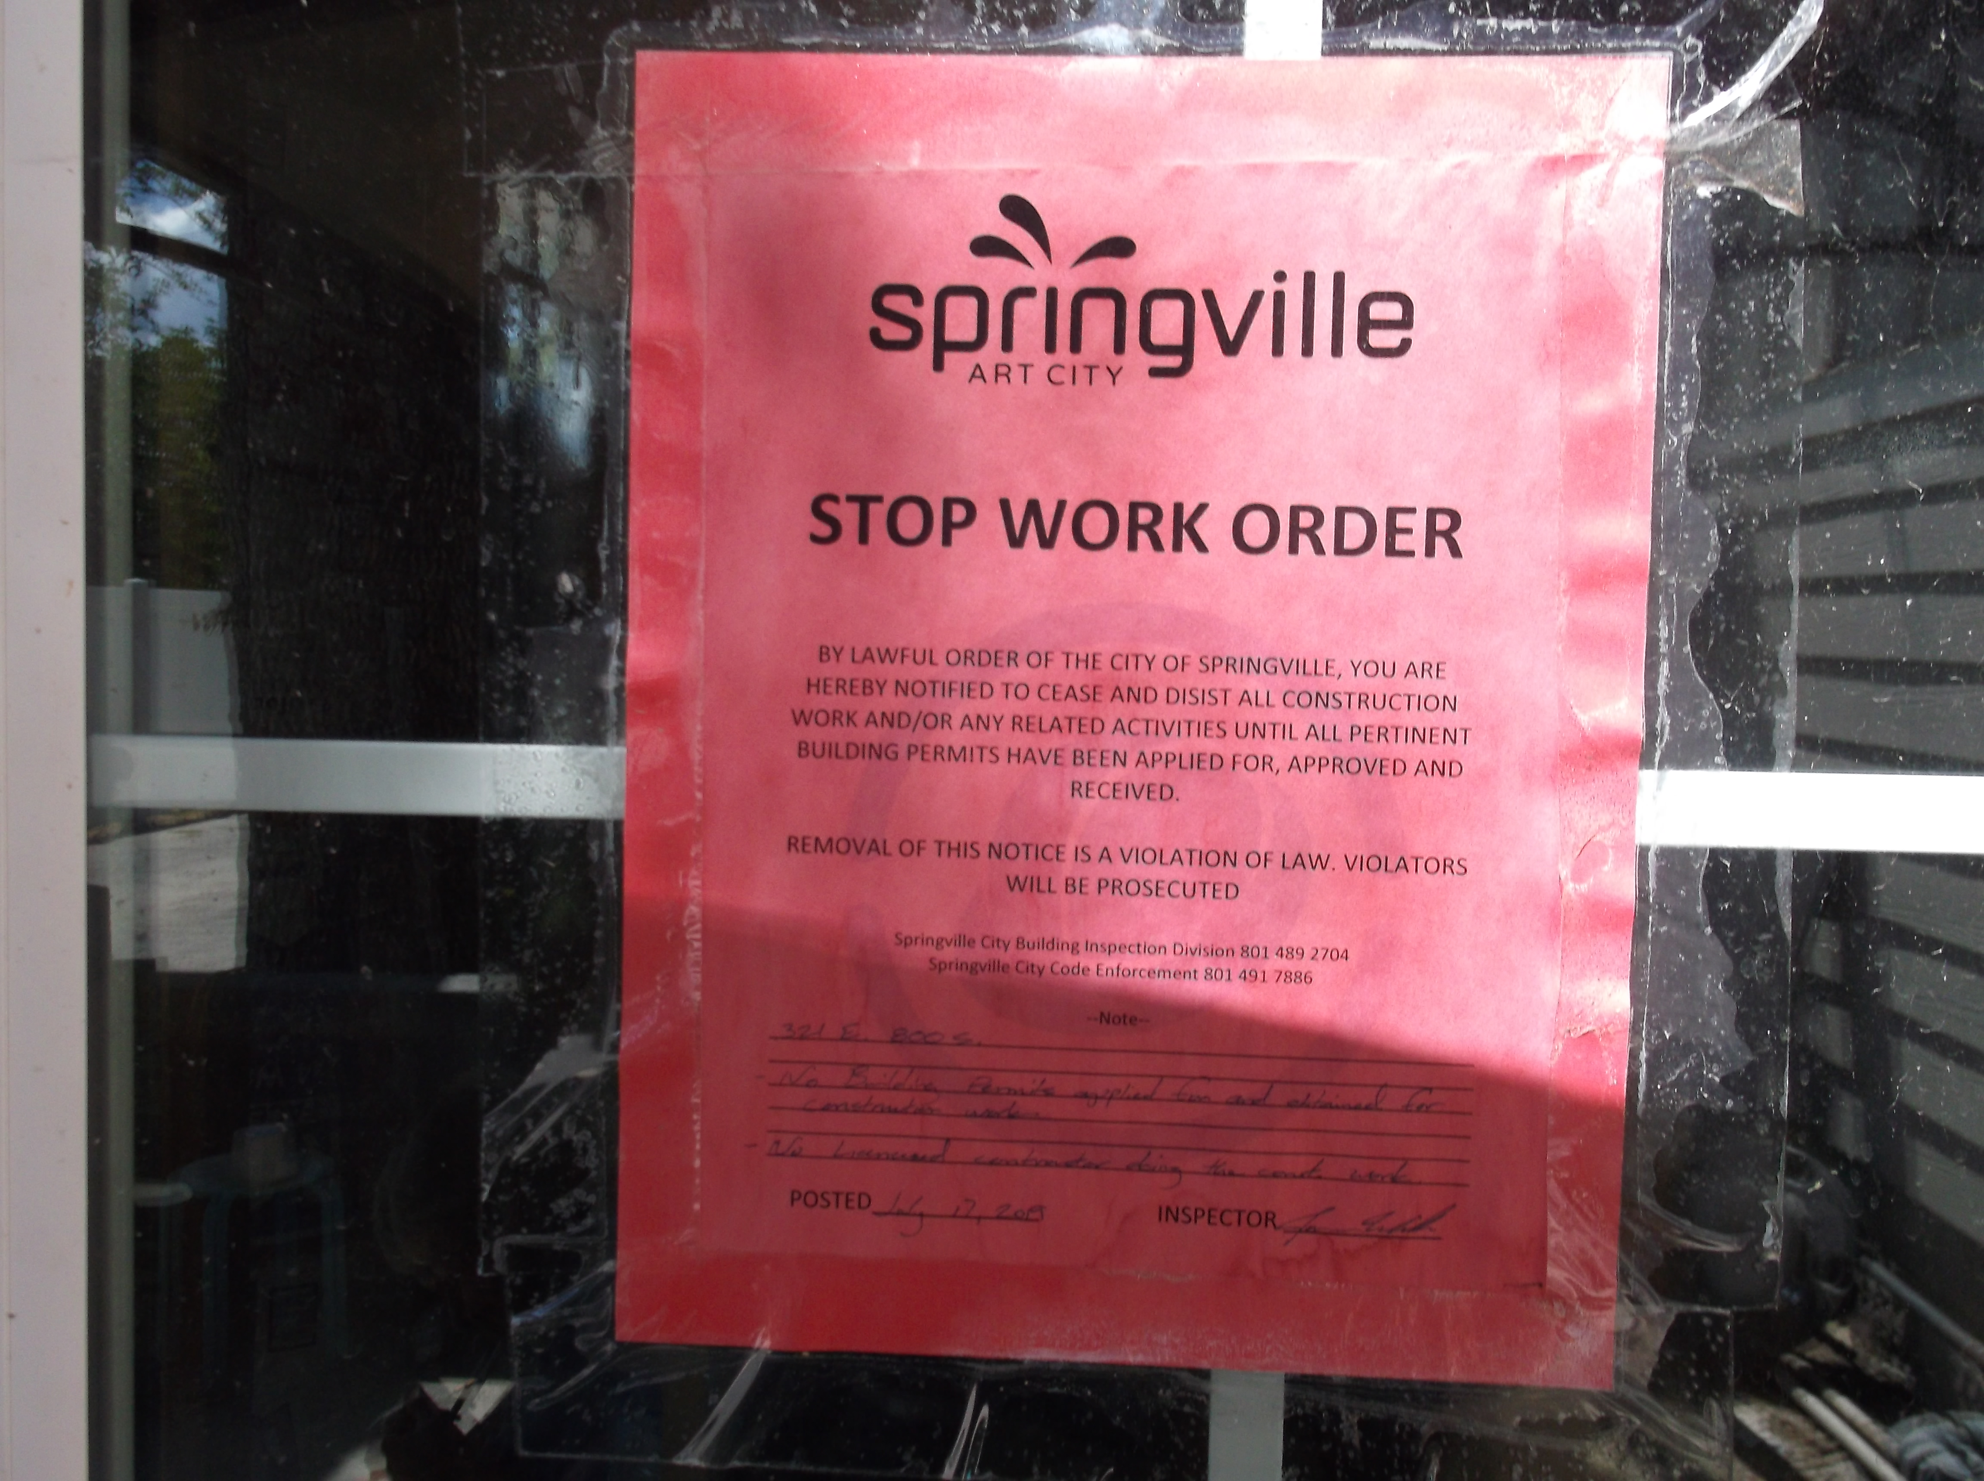

Work in progress on roof 2019-08-20. Not AF line.
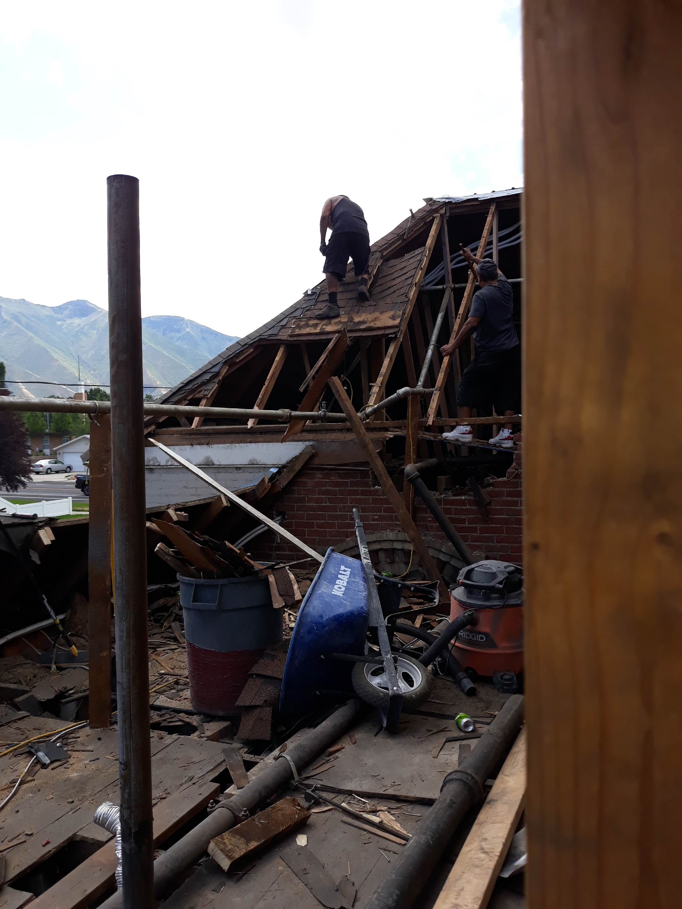

Temp Fire clearance expired.
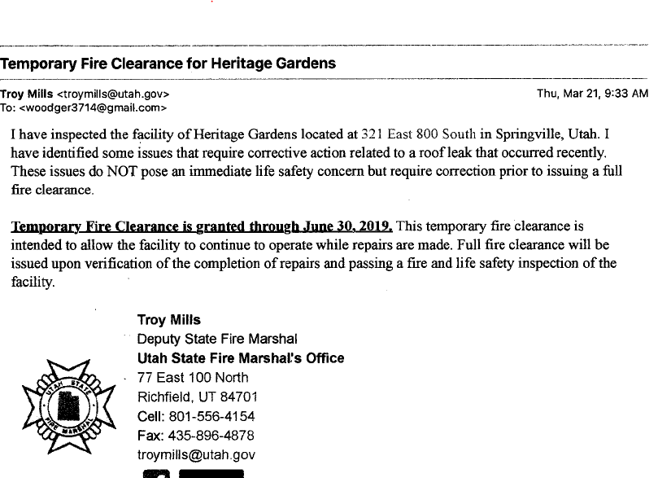

State FM Deficiencies report -2 pages

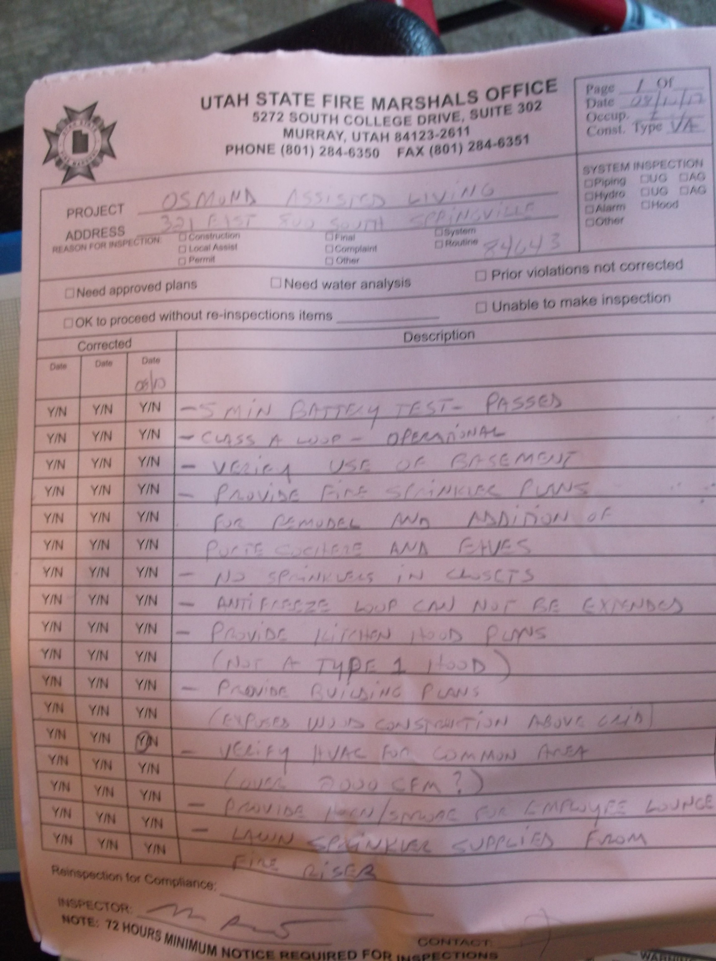
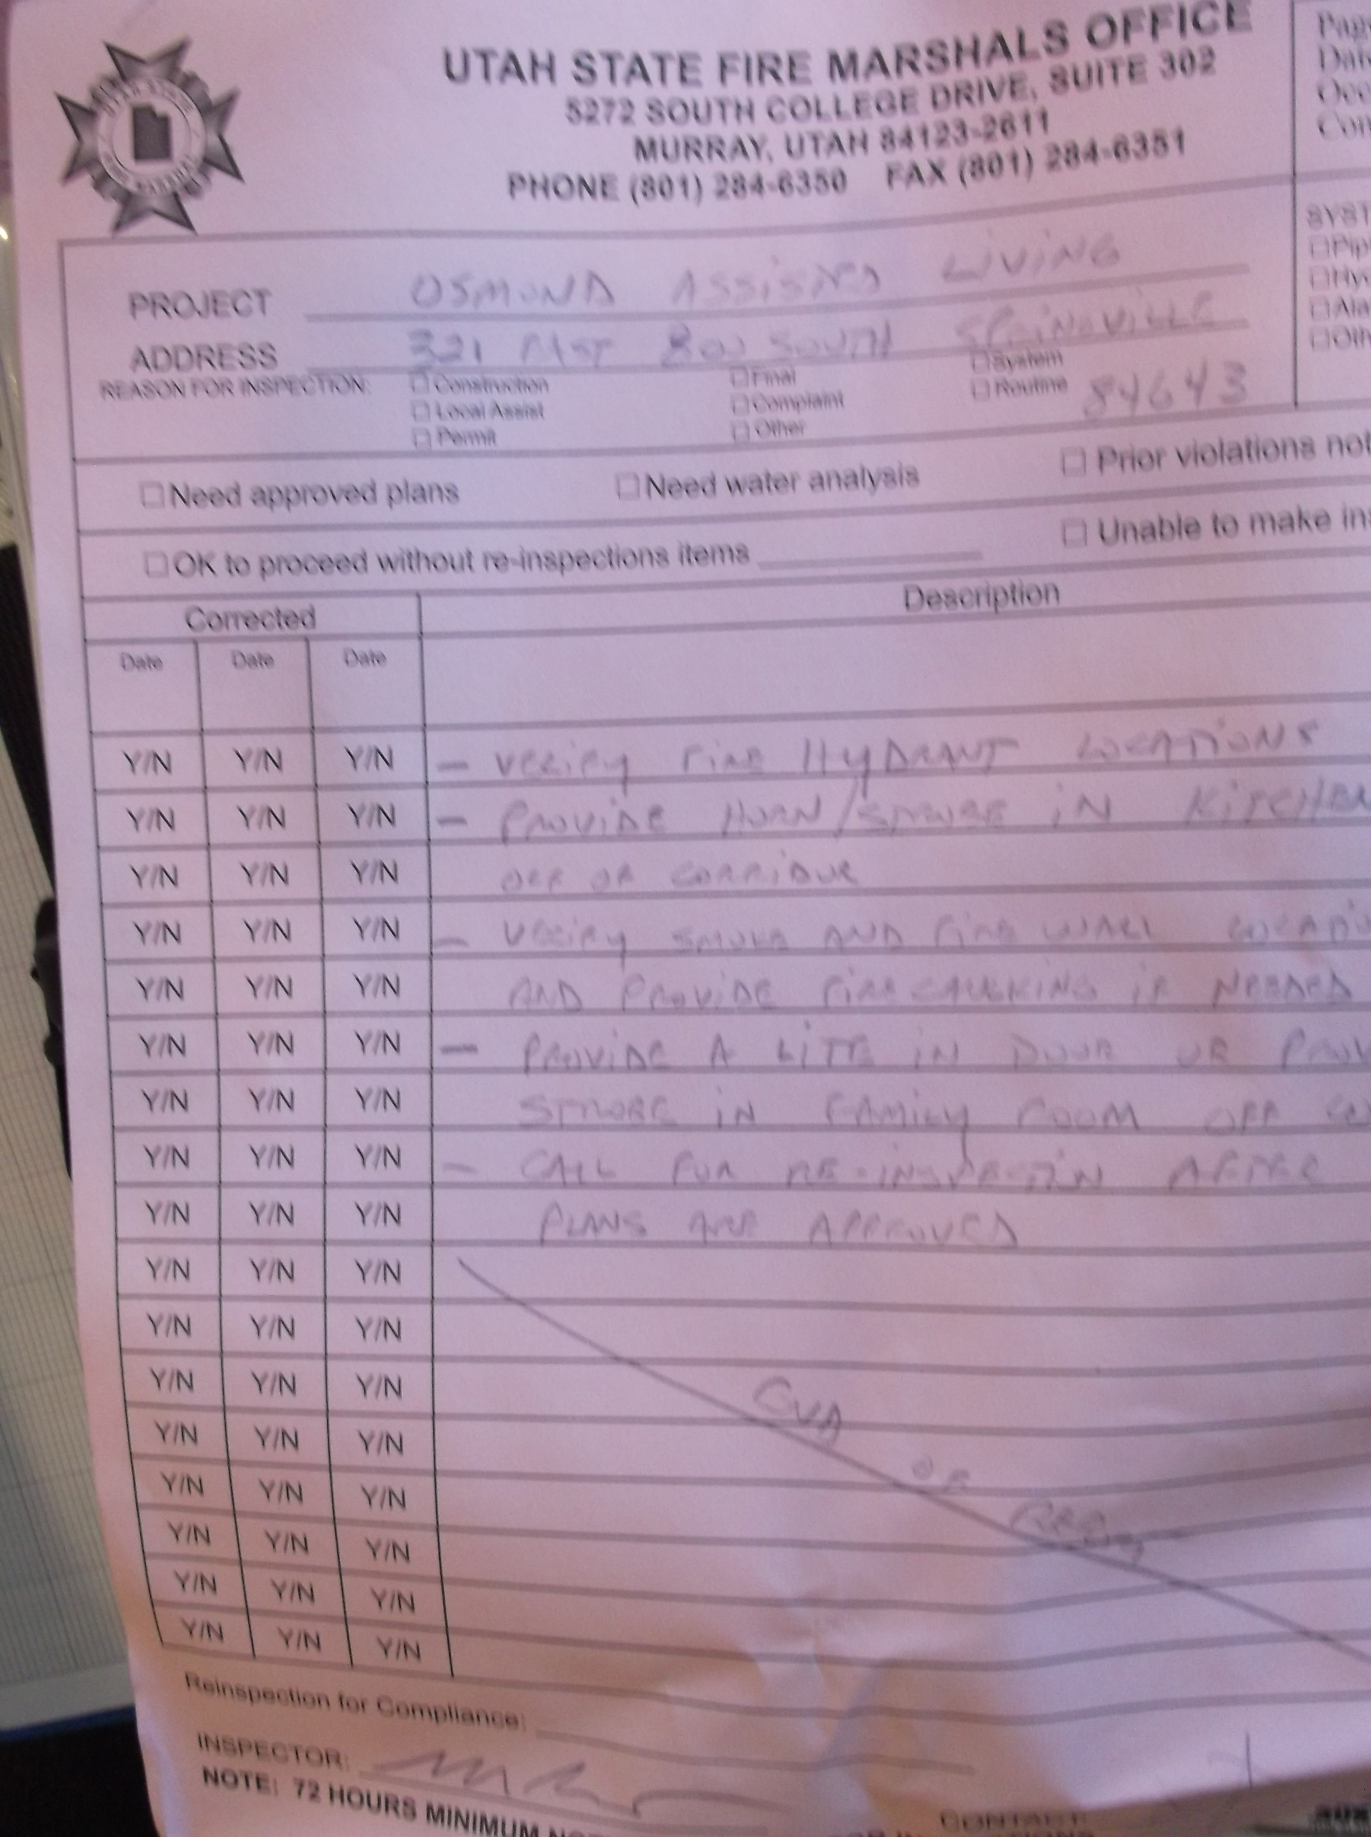
New addition to Antifreeze system
