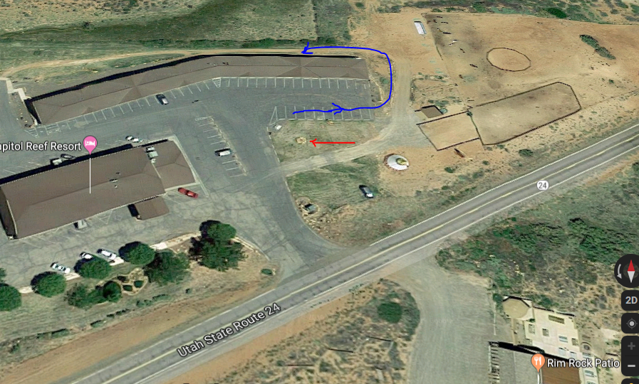

Red is Hydrant

Blue is path you take to go around back then down to the lower level,

Enter door to Maids Room (at blue arrow head), for Riser Room.