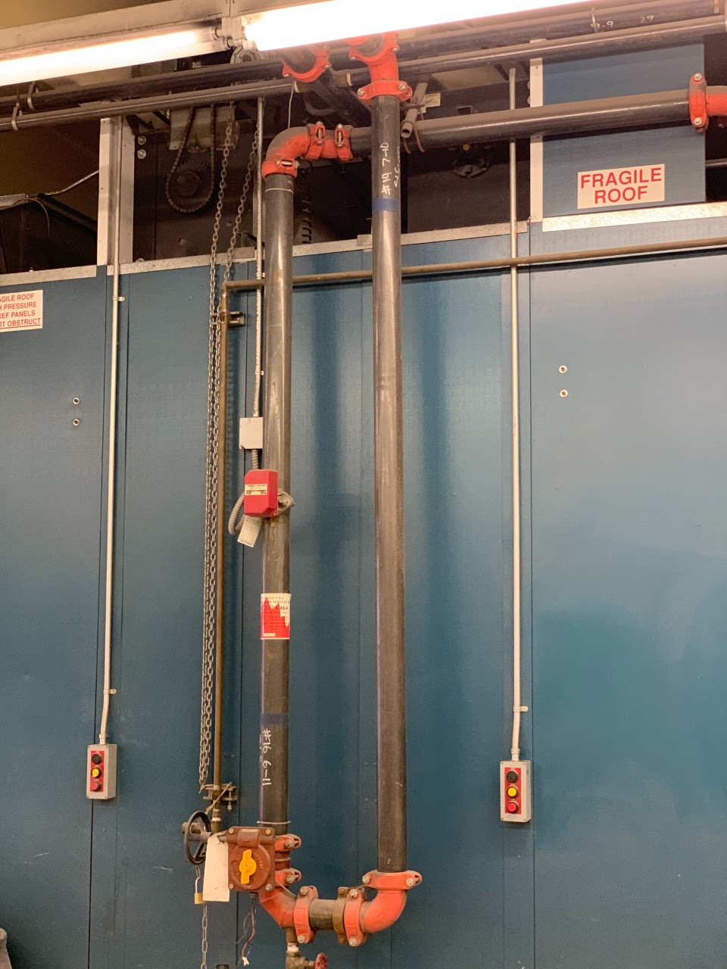 | To Booth heads??query?  Inlet?  If so, can we  move  To upper point, back a pace, and cap off after, on the horizontal?

