YOU are receiving this because your site at: Click here to enter Address Fire Riser valve stack & alarm devices WILL BEGIN being monitored by us. (Start 2021-April-01)
YOU are on the ‘Party List’ for Click here to enter Job Name Alarm callout.
In regard to CMS calling those on the party list:
If you have folks on your Party List, they must be prepared to answer that call.
- Please instruct those who are on your Party List on the following points:
  - That they MUST allow/accept: 1 773 725-0222 on their phone.
    - It is from Emergency 24 Central Monitoring Service (AKA E24 CMS)
  - Party List members must know the alarm account number
  - Party List members must know the password/s
    - You can have different passwords for various options.
  - Party List members must answer the call from 773-725-0222.
    - The operator has already sent the Fire Department to your site, before calling 'you'
    - The operator is then following your instructions when you signed up, to call those listed on your Party List.
    - If the Operator cannot get anyone on the list, they notify Fire Suppression Services, and mark your number for deletion.
    - We carry out a follow up, the next business day.
    - If you do not answer the follow up, you are confirmed as a ‘marked for deletion’.
- Party List members must know the alarm account number:
  - YOUR ACCOUNT Number is: Click here to enter E24 account for the Click here to enter address site.
- .... and they must know the passwords
  - Ask your supervisor for your password.

For the FACP Installer
Points to Note:
- Non FSS Alarm technicians may need to know:
  - The account number and the password to place in test,
  - They need to know the Receivers:
    - Primary: (800) 438-6265 Secondary:(800) 438-6268
  - The installer MUST SEND the Dialer Report to
    - arunfss@live.com at Fire Suppression Services Inc.
    - Dialer Report to be in either CMS or SAS format.
    - Phone me on (801) 440-9906 when you’ve sent it.
- Our Technicians (FSS) are issued with our master password.
  - Do not give them your password.

More often I am called, or the CMS is called, to place the FACP in test, for inspections, and ... if the FACP is not operational for any reason, local Fire Marshal needs to know because Fire Watch is required.

If you need more information, I can give it to one who can answer the password question correctly. I can also make changes as necessary.
And .. I suggest that you advise us of your open & close times.

Legend:
CMS = Central Monitoring Station. | E24 = Emergency24
Napco =Starlink | C24 = Connect24
FACP = Fire Alarm Control Panel
EACP = Evacuation Control Panel/with Voice Evacuation
AHJ = Authority Having Jurisdiction. (Fire Marshall, Building Inspector etc.)

Your alarm Panel | Your Cell Dialer  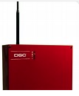 | 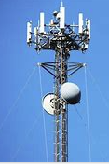 | NOC Network Operations Centre
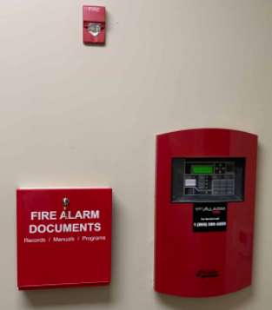 | copper phone lines | Verizon or AT&T Cell network  CO-Verizon or AT&T | 
Via IP or Dial Number,
to a Line Card

Emergency 24 Operator
AKA E24
773-725-0222
Central Monitoring Station. AKA CMS

IF ALARM | IF TROUBLE

NOTIFY

- FIRE DEPARTMENT-POLICE-EMS  - PARTY LIST  - FIRE SUPPRESSION SERVICES LOG |  | - PARTY LIST  - FIRE SUPPRESSION SERVICES LOG

And we may then call your Party List


Fire Suppression Services inc.
Fire Alarm Company
(801) 277-6464

