Steve Floor,
Underground is in the purview of Division 33 11 13.23 Plastic Public Water Utility Distribution Piping
And: Division 33 11 19 Fire Suppression Utility Water Distribution Piping, and Div-31/33 Trench & Backfill to supply underground utility water to sprinkler riser.
Not our area. We are Div-21
Suggested parts with corresponding pricing:
- Parts below are suggested as may be required.
- No design is implied
- No flow tests implied
- Sales tax not included
This document must in no way be interpreted as a design.
Elbow  Approx. two required @ $55 ea | 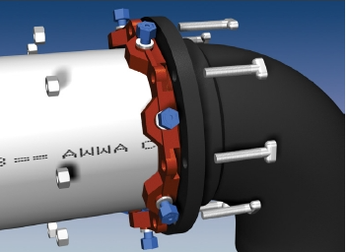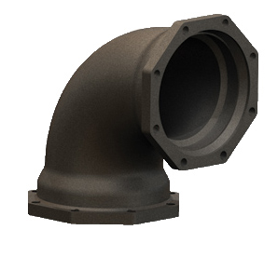
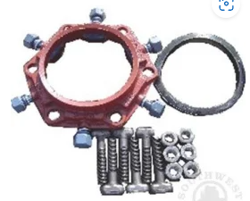 | Wedge-Action Joint Restraint  Approx. $110 ea
Joint-Restraint  Approx. 6 required at approx. $399 ea | 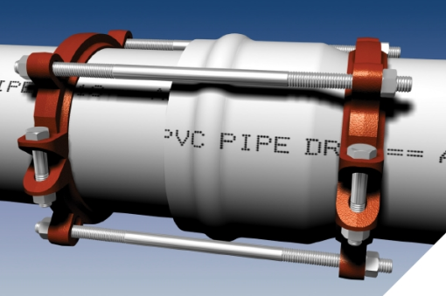
C900 Joint | 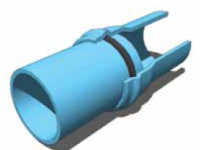

Break-away flange  Two required @ approx. $266 ea | 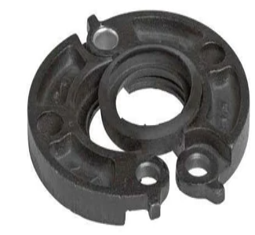
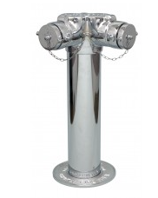 | Free Standing FDC  Two suggested @ approx. 2,667.00 each.
C900 SDR 18 Pipe 4”  $375.00 per 20 ft length  8 to 9 lengths suggested. | 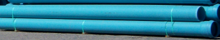
Allow for miscellaneous items 9% | Pipe-Cement, pipe-wrap, Concrete and Bollards etc.
