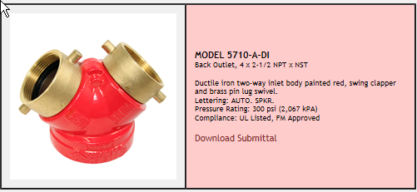
Two-Way with Single Clapper
Function: Used as an auxiliary inlet connection providing 500 GPM/1892 lpm minimum to supplement the fire protection water supply. Swing clapper provides unobstructed waterway. Exposed design is an economical method of satisfying fire dept inlet requirements.
Regularly Furnished: Cast brass two-way inlet body, swing clapper and pin lug swivel. Back or angle outlet as selected by model number. Lettering as selected. Size 4"/10.2cm X 2½" X 2½"/6.4cm X 6.4cm.
Optional Finishes:
-B Polished Brass
-C Rough Chrome Plated
-D Polished Chrome Plated
Lettering Available:
Auto Spkr or Standpipe
Specify: Thread and lettering

http://www.potterroemer.com/component/page,shop.product_details/flypage,shop.flypage/product_id,447/option,com_virtuemart/Itemid,4/

