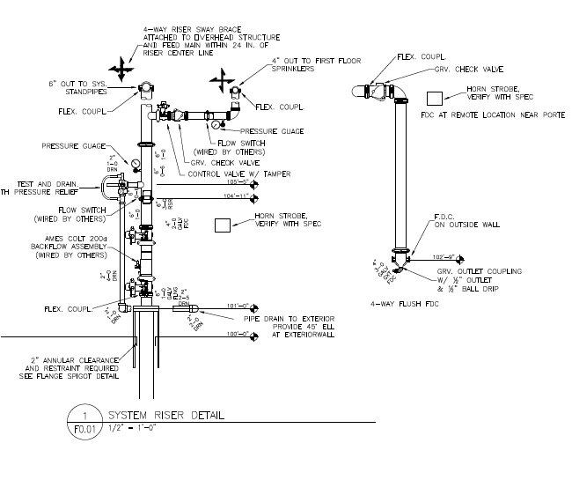

Riser stack installations differ.

This drawing may not represent your riser stack