YOU are receiving this because your site at: Click here to enter Address Fire Riser valve stack & alarm devices WILL BEGIN being monitored by us. (Start 2022-Oct-01)
YOU are on the ‘Party List’ for Click here to enter Job Name Alarm callout.
In regard to CMS calling those on the party list:
If you have folks on your Party List, they must be prepared to answer that call.
If you want text alerts, enroll at: http://em24Alerts.com/Text or text: enroll to (773) 725-4000 (Know your act# & password)
- Please instruct those who are on your Party List on the following points:
  - They MUST allow/accept: 1 773 725-0222 on their phone.
    - It is from Emergency 24 Central Monitoring Service (AKA E24 CMS)
  - Party List members must answer the call from 773-725-0222.
  - Party List members must know the alarm account number
    - YOUR ACCOUNT Number is: Click here to enter E24 account for the Click here to enter address site.
  - Party List members must know the password/s
    - Ask your supervisor for your password.
    - Your site may have different passwords for various options.
  - Because if it is an ALARM:
    - The operator has already sent the Fire Department to your site, before calling 'you'
    - The operator is then following your instructions when you signed up, to call those listed on your Party List.
    - If the Operator cannot get anyone on the list, they notify Fire Suppression Services, and mark the unanswered number for deletion.
    - We carry out a follow up, the next business day.
    - If you do not answer the follow up, you are confirmed as a ‘marked for deletion’.

For the FACP Installer
Points to Note:
- Non FSS Alarm technicians may need to know:
  - The account number and the password to place in test,
  - They need to know the Receivers if TelCo:
    - Primary: (800) 438-6265 Secondary:(800) 438-6268
  - The installer MUST SEND the Dialer Report to
    - arunfss@live.com at Fire Suppression Services Inc.
    - Dialer Report to be in either CMS or SAS format.
    - Phone me on (801) 440-9906 when you’ve sent it.
- Our Technicians (FSS) are issued with our master password.
  - Do not give them your password.

More often I am called, or the CMS is called, to place the FACP in test, for inspections, and ... if the FACP is not operational for any reason, local Fire Marshal needs to know because Fire Watch is required.

If you need more information, I can give it to one who can answer the password question correctly. I can also make changes as necessary.
And .. I suggest that you advise us of your open & close times.

Legend:
CMS = Central Monitoring Station. | E24 = Emergency24
Napco =Starlink | C24 = Connect24
FACP = Fire Alarm Control Panel | NOC = Network Operations Center
EACP = Evacuation Control Panel/with Voice Evacuation
AHJ = Authority Having Jurisdiction. (Fire Marshall, Building Inspector etc.)

Note: Text messaging is for ‘Troubles’ only; the panel is beeping. It is the Fire Alarm panel advising that it senses a fault, and you need to look at the log. With a ‘Trouble’ you will get a text message. You need to acknowledge the text, or a voice call will follow. Once you ascertain what is causing the fault, call me to schedule a service technician. An ‘ALARM’ will be very loud bells/sirens and flashing lights and the Fire Department is called. Leave the building. Make sure all staff know how to evacuate the building.

Your alarm Panel  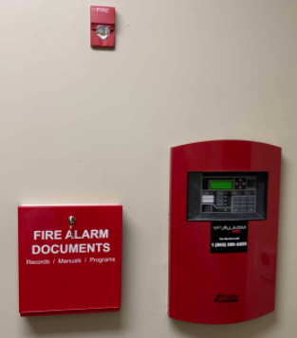 or | Your Cell Dialer  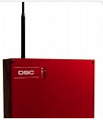  DSC  Connect24  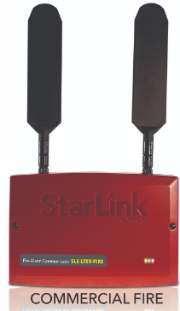Starlink/NapCo | Verizon or AT&T Cell network  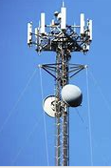 | NOC Network Operations Centre
 | copper phone lines | CO-Verizon or AT&T | 
Via IP or Dialed Number, to a Line Card

Emergency 24 Operator
AKA E24
773-725-0222
800 827-3624
Central Monitoring Station. AKA CMS

IF ALARM | IF TROUBLE

NOTIFY

- FIRE DEPARTMENT-POLICE-EMS  - PARTY LIST  - FIRE SUPPRESSION SERVICES LOG |  | - PARTY LIST via sms text &/or phone  - FIRE SUPPRESSION SERVICES LOG

And we may then call your Party List

Fire Suppression Services inc.
Fire Alarm Company
(801) 277-6464
NB: An ALARM is loud and the Fire Dept. arrives. A TROUBLE is a ‘beeping’ at the Fire Panel.

