Fire Suppression Services Incorporated
3802 South 2300 East, Millcreek City. UT 84109
Ph (801) 277-6464
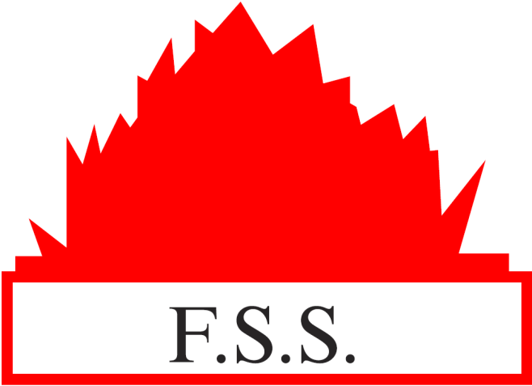
SeeJobName in zzJobData-docx file
SeeSt in zzJobData-docx file
SeeCity in zzJobData-docx file
NFPA 25
FAQ’s
Water-Based Sprinkler System
Inspection, Testing & Maintenance

